UNLIMITED 2026
REGENCITY GRID INDONESIA: HARNESSING URBAN KINETIC ENERGY AS DISTRIBUTED GRAVITY BATTERIES TO ACCELERATE INDONESIA'S SMART ENERGY TRANSITION
SUBTHEME: SMART ENERGY TRANSITION: RENEWABLE INNOVATION AND DIGITAL GRID OPTIMIZATION



Prepared by:
David Muhammad Thorique - 2506536774 - 2025
Fauzi Fadhlurrohman - 2406406080 - 2024

UNIVERSITAS INDONESIA
DEPOK
2026

LIST OF FIGURES
Figure 1. ReGenCity integrated architecture
Figure 2. Indicative ReGenPort Recovery Node concept
Figure 3. Indicative ReGenTransit Recovery Node concept
Figure 4. Indicative ReGenFlow Recovery Node concept
Figure 5. North Jakarta pilot cluster, candidate sites pending gates
Figure 6. Simplified 24-month phase-gated pilot timeline
Figure 7. Ten-year base-case capital recovery
Figure 8. Indicative five-year and ten-year operational impact under the base case

LIST OF TABLES
Table 1. Novelty boundary and integration logic
Table 2. Principal pilot risks and controls
The Appendix Dossier Map lists supporting tables and figures by appendix section.

1. INTRODUCTION
Cities are where the global energy transition will be won or lost, not power plants. They generate roughly 80 percent of global GDP and were responsible for a record 29 billion tonnes of carbon dioxide in 2023 alone (IEA, 2024). More than half of the world's 8 billion people already live in urban areas, and that share is projected to climb toward 70 percent by 2050, adding nearly 2 billion new urban residents within three decades (IEA, 2024). Some of the projections cited in that same analysis suggest peak urban electricity demand could triple by 2030 as cooling, transport, and industry electrify at once (IEA, 2024). Whatever the exact number turns out to be, the direction is not in question. The question this essay takes up is what happens to that expanding load once it starts moving through a city's own machinery, not just how much of it a grid can supply.
The growth itself is already measurable. Global electricity demand rose 4.3 percent in 2024, the sharpest increase in years, and the IEA expects consumption to keep expanding by roughly 3.9 percent annually through 2027, adding the equivalent of one Japan's worth of electricity consumption to the world every year, with emerging economies accounting for an estimated 85 percent of that growth (IEA, 2025a). Indonesia sits squarely inside that trend, with national electricity demand projected to double by 2040, driven by the same forces of urbanization reshaping cities everywhere else (IEA, 2021). Governments have responded to this trajectory with real commitments. At COP28 in Dubai, the UAE Consensus set a 2030 target to triple global renewable capacity and double the annual rate of energy efficiency improvement (IEA, 2024). Only one of those targets has moved anywhere near the pace required. Global energy efficiency progress improved by just 1 percent in 2024 and roughly 1.8 percent in 2025, still well short of the near 4 percent annual rate the COP28 goal (IEA, 2025b).
Generation capacity, meanwhile, has expanded fast enough to outrun the grids meant to receive it. More than 3,000 gigawatts of renewable power projects are currently stuck waiting for grid connection worldwide (IEA, 2024). That queue is the clearest evidence available that the constraint on the energy transition is no longer only how much clean electricity the world can produce. It is what happens to electricity after it reaches a city and starts doing work, moving cargo, running trains, pressurizing water mains, because a meaningful share of that electricity is not lost to inefficiency in the abstract. It is discarded, on purpose, by machines cities already operate every day.
A port crane draws power to lift a loaded container and then throws that energy away as heat the moment it lowers the same container back down, unless a regenerative drive is fitted to catch it. Where that fitting exists, the reversed flow is large enough that the crane's primary power source can be downsized without losing lift capacity (Zhao et al., 2014). A train converts a comparable share of its kinetic energy into electricity every time it brakes into a station, and a widely cited engineering review treats recovering that energy, whether through onboard storage, wayside storage, or reversible substations, as an established practice rather than an experimental one (González-Gil et al., 2013). A water utility discards energy more quietly still, throttling high-pressure flow through valves that exist purely to protect pipes. A 2021 review of pump-as-turbine technology found this recovery method underused relative to other renewable sources despite being simple and economically viable, with a single documented case network holding more than 370,000 kWh of recoverable energy a year (Souza et al., 2021).
What these three mechanisms share, mechanically, is gravity. A crane lowering a container, a train shedding momentum, water dropping pressure down a pipe are all instances of a mass or a fluid giving up potential energy that a generator can intercept before it becomes waste heat. That is also the exact physical principle behind a gravity battery, a storage technology built specifically to raise a mass with surplus electricity and lower it later to recover that electricity (Cai et al., 2024). Gravity batteries are matured today mainly as pumped hydro, but the same review documents growing interest in purpose-built towers, mineshafts, and rail-mounted weights (Cai et al., 2024). Every system catalogued in that literature, from pumped hydro to tower, shaft, and mountain-based storage, is something that has to be built from scratch. Cities running ports, elevated rail, and pressurized water networks already operate the physical equivalent of a gravity battery, at scale, every single day. Nobody has switched it on.
The technologies needed to switch it on are not the missing piece. Regenerative crane drives, wayside braking storage, and pump-as-turbine systems have each been documented in the engineering literature for more than a decade (Zhao et al., 2014; González-Gil et al., 2013; Souza et al., 2021). What has never existed is a way to treat them as one system. A crane retrofit sits inside a port authority's books, a wayside storage unit inside a rail operator's maintenance budget, a pressure-recovery turbine inside a water utility's capital plan, each measured on its own terms. A recent systematic review of how distributed energy resources are aggregated found the same problem at a much larger scale, a persistent lack of shared definitions and standards for treating different types of distributed assets as one measurable portfolio (Adham et al., 2025). A port cannot show its recovered kilowatt-hours against a rail line's under those conditions. No regulator can currently ask either one to prove the number is real.
None of the energy at stake here needs to be invented. It already moves through cranes, trains, and water mains every hour of every day, discarded not because it lacks value but because nothing yet exists to catch it, measure it, and vouch for its number. That is a gravity battery sitting switched off across an entire city, and what keeps it off is institutional, not technical. The same absence holds in any city that runs a port, an electrified rail line, or a pressurized water main, not only in Jakarta. ReGenCity Grid Indonesia is the protocol built to close that absence, a phase-gated retrofit and verification standard that layers shared metering, mandatory safety and service gates, and federated dispatch over recovery technologies that already exist. North Jakarta carries the first test of that standard, deliberately conservative, because what the pilot proves there is what earns the case to run it everywhere else.

2. BODY

2.1 Scientific Basis and System Boundaries of Urban Energy Recovery
This section sets the technical boundary of the proposal. It defines what counts as recoverable energy, what does not, and why the base projection stays conservative.
Cities use electricity to lift containers, accelerate trains, and maintain water pressure. The same systems lose energy when cranes lower loads, trains brake, and valves reduce pressure. ReGenCity treats the lost fraction as an efficiency resource. The platform recovers energy only from operations required for cargo, mobility, or water service. Local loads receive the recovered electricity first. Storage receives surplus after local demand has been served.
The accounting boundary is strict. Net recovery equals the reduction in facility feeder imports after conversion, storage, and auxiliary losses. Baseline models adjust for cargo mass and height, train service and speed, and water flow and pressure head. Upstream pumping is deducted from water recovery. Storage discharge is counted once. These controls follow IPMVP and ISO 50015 principles. The full accounting boundary appears in Appendix 4.1.
No field measurements exist yet. The essay reports screening projections rather than observed results. The conservative, base, and optimized cases produce 0.257, 1.153, and 3.799 GWh per year. The base case consists of 0.690 GWh from ports, 0.142 GWh from transit, and 0.320 GWh from water-pressure recovery. The evidence classes appear in Appendix 3.1. The uncertainty register appears in Appendix 3.3. Detailed anchor calculations appear in Appendices 4.2 to 4.5.

2.2 ReGenCity Grid Indonesia: Integrated Architecture and Defensible Novelty
This section explains how the proposal works as a coordinated retrofit system. The focus is operational discipline, not a claim of invention for each individual component.
ReGenCity is a retrofit and coordination standard. Each candidate site receives a Recovery Node with a meter, sensors, a local safety controller, secure communications, and a converter or short-duration buffer where needed. ReGenCity OS receives a verified flexibility envelope from each site. The envelope states available power, duration, operating limits, and owner restrictions. The city layer coordinates data and dispatch requests. The sites do not form one physical microgrid. Storage and flexibility rules appear in Appendix 4.6. Figure 1 presents the federated architecture at proposal level.
Regenerative crane drives, wayside rail storage, pumps-as-turbines, digital twins, and virtual power plants already exist. ReGenCity does not claim those technologies as new. The proposal combines a common Recovery Node, service-first gates, one measurement protocol, the Urban Recoverability Index, and federated dispatch across separate asset owners. The prior-art comparison and novelty boundary appear in Appendix 3.2.
Table 1. Novelty boundary and integration logic
Element | Already established | ReGenCity integration claim
Recovery equipment | Crane regeneration, wayside storage, and pumps-as-turbines already exist. | Applies a common Recovery Node standard across different urban assets.
Digital coordination | Forecasting, telemetry, and dispatch tools already exist. | Limits coordination to verified envelopes, local authority, and owner veto.
Screening and selection | Site studies are common but often asset-specific. | Uses mandatory gates and one Urban Recoverability Index across sectors.
Measurement and governance | Metering and M&V methods exist in separate domains. | Uses one claim register, one M&V logic, and a common evidence discipline.
Moved from Appendix 3.2 to foreground the proposal's bounded novelty.
Artificial intelligence supports forecasts and bounded recommendations. Local controllers enforce hard limits, and operators retain veto authority. A communications failure returns each site to safe local control. The AI challenger stays in shadow mode unless testing shows at least 3 percent more net value than the rule-based controller with zero accepted constraint violations. The control hierarchy appears in Appendix 4.7. Synthetic validation and the indicative operator interface appear in Appendix 4.8.
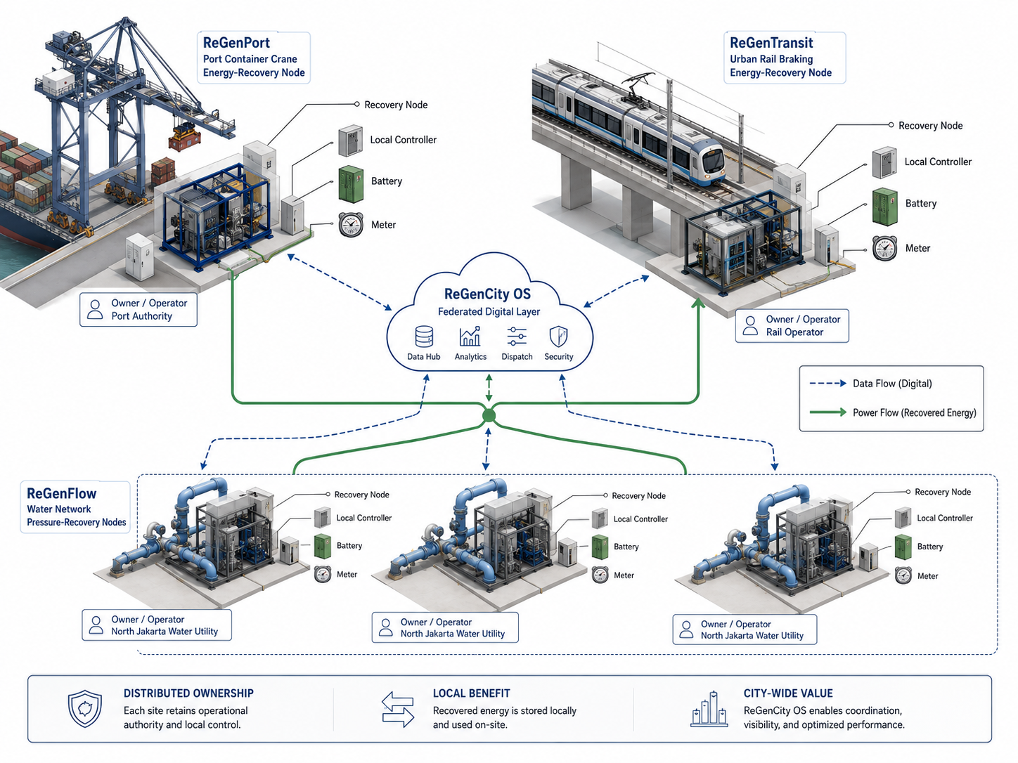
Figure 1. ReGenCity integrated architecture. Recovered energy stays under site control, while ReGenCity OS coordinates verified data and qualified flexibility.
Source: Authors' engineering concept render, 2026.

2.3 Three Recovery Anchors and Digital-Grid Operating Mechanism
This section explains the physical conversion path inside each Recovery Node. Each node follows the same operating rule: recover energy from a required service, use it locally, store only unmatched surplus, and stop recovery when the primary service approaches a limit.

2.3.1 ReGenPort: Crane Lowering-Energy Recovery
A crane draws electrical power when the hoist motor lifts a container. During lowering, the descending mass drives the same motor, and the variable-frequency drive operates in regenerative mode. The drive returns electricity to the crane DC bus instead of sending the full braking pulse to resistors or other dissipative equipment. This principle follows established crane energy-management practice (Alasali et al., 2019).
The terminal uses the recovered electricity first. A nearby crane, auxiliary equipment, or another coincident terminal load absorbs the pulse when demand is available. When local demand is lower than the regenerative pulse, a bidirectional conv red erter directs the unmatched fraction to a supercapacitor or battery. The local controller monitors DC-bus voltage, motor torque, converter status, storage state of charge, and temperature. It isolates the recovery package when any limit is exceeded, while the certified crane controls continue independently.
The screening model applies E = mgh x drive efficiency x otherwise-unabsorbed share x delivery efficiency. The base case produces 0.690 GWh per year from one million eligible descents, a 30-tonne average mass, a 25-metre descent, and conservative conversion factors. The model counts only energy that the existing crane system would otherwise reject. The complete calculation appears in Appendix 4.2.
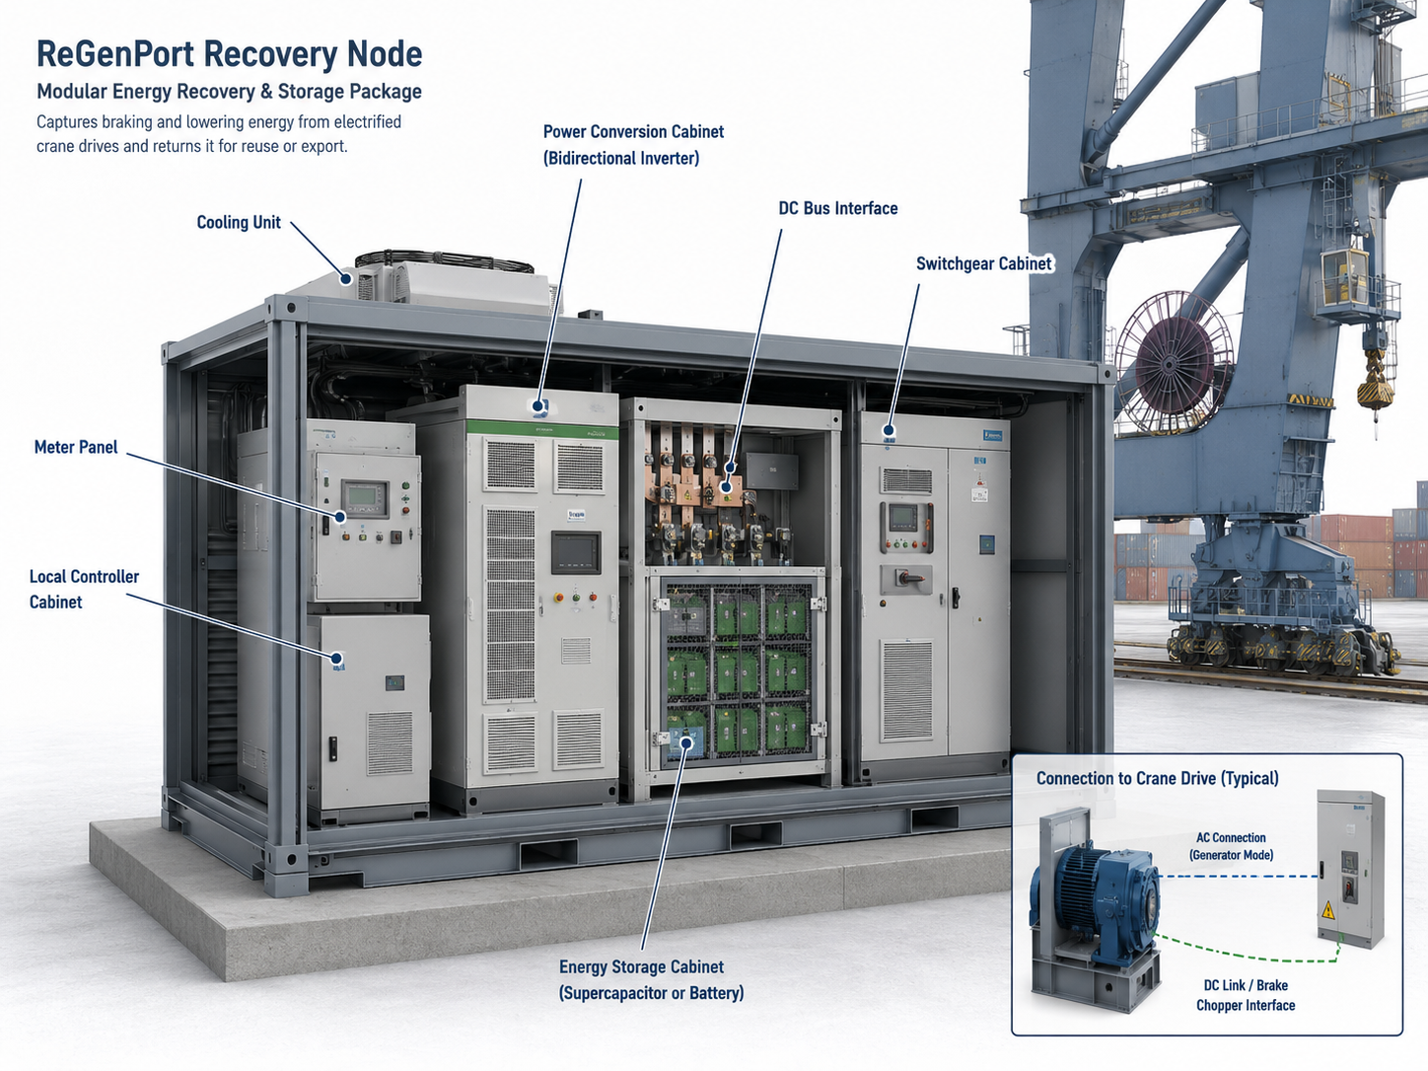
Figure 2. Indicative ReGenPort Recovery Node concept. The package connects the crane DC bus to metering, local control, power conversion, and short-duration storage.
Source: Authors' engineering concept render, 2026.

2.3.2 ReGenTransit: Regenerative Braking Recovery
During electric braking, the traction motors operate as generators and convert part of the train kinetic energy into electricity. The traction DC network receives this energy first. A simultaneously accelerating train or an available station load absorbs the pulse when the network is receptive. When line voltage rises or no receptive load exists, the remaining energy is normally dissipated. A published subway study found that 77 percent of braking energy returned to the network while 23 percent remained dissipated, which shows why the proposal must measure the otherwise-unabsorbed fraction (NYSERDA, 2023).
The wayside Recovery Node connects to the traction power interface through protection and conversion equipment. An inverter or rectifier conditions the short braking pulse and charges a supercapacitor bank. Station systems or later traction demand then use the stored electricity. The local controller monitors traction voltage, current, storage state of charge, temperature, and equipment availability. It does not change the braking command, train timetable, or certified rail protection logic.
The screening model applies E = 1/2 mv^2 x electric-braking efficiency x otherwise-unabsorbed share x delivery efficiency. The base case produces 0.142 GWh per year from 383,250 eligible stops and transparent assumptions for train mass, speed, and line receptivity. The complete calculation appears in Appendix 4.3.
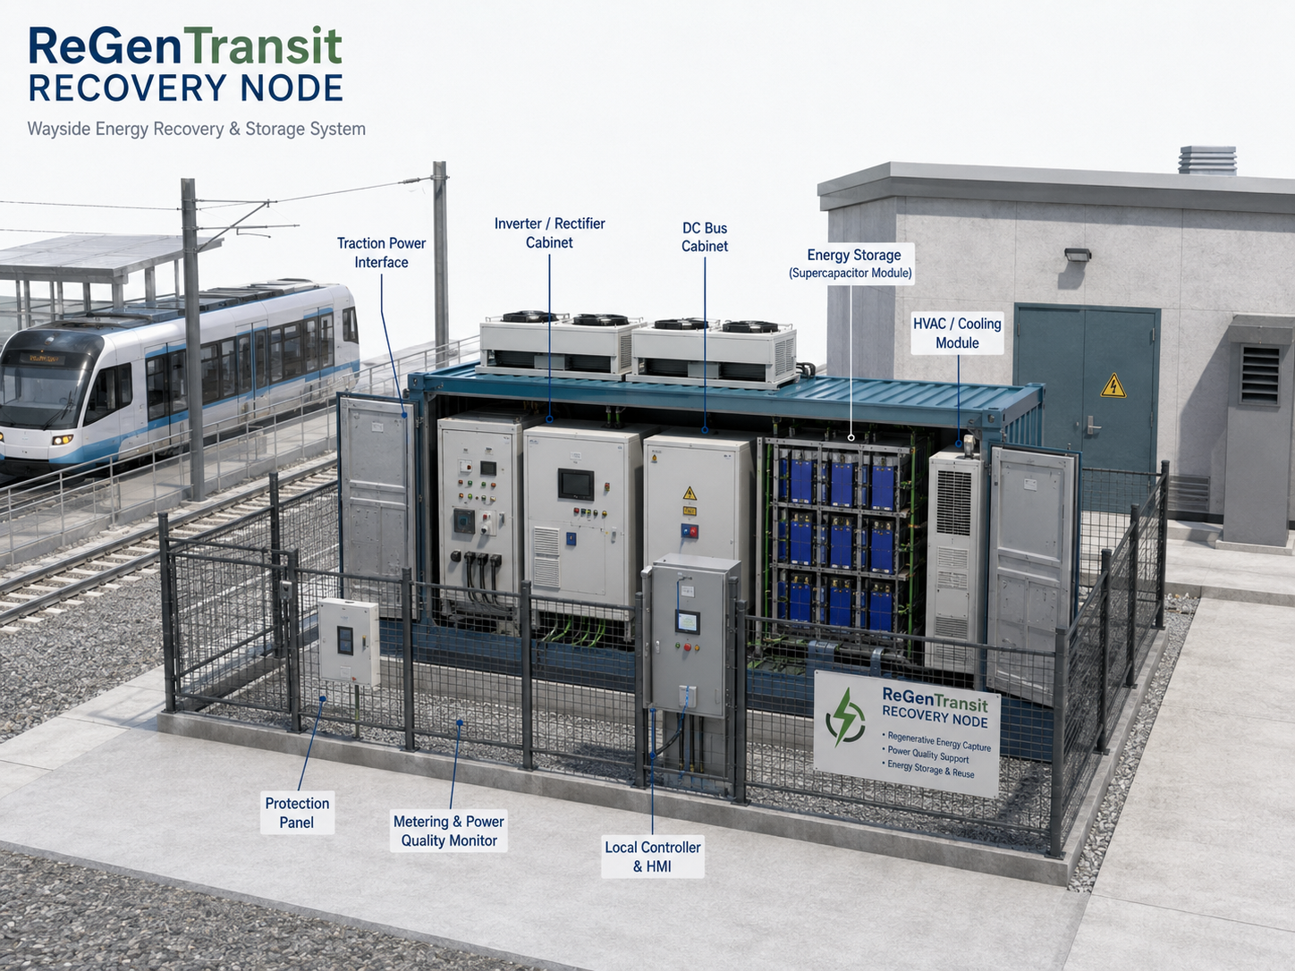
Figure 3. Indicative ReGenTransit Recovery Node concept. The wayside package captures braking energy that the traction network cannot accept and stores it for later local use.
Source: Authors' engineering concept render, 2026.

2.3.3 ReGenFlow: Water-Pressure Energy Recovery
Water networks often reduce excess pressure through a valve. ReGenFlow replaces part of this pressure drop with a pump-as-turbine or microturbine. Water entering at higher pressure drives the runner, the shaft rotates a generator, and the generator supplies electricity to the water facility. This approach follows established pressure-recovery applications in water distribution systems (Kramer et al., 2018; Muhammetoglu et al., 2018).
A programmable controller regulates the turbine and bypass line to keep outlet pressure inside the required service band. Isolation valves and the bypass preserve water delivery when the turbine stops, demand changes, or maintenance begins. Flow, inlet pressure, outlet pressure, generated electricity, auxiliary demand, and bypass status are metered. Local facility loads receive the electricity first. The calculation deducts auxiliary consumption and any additional upstream pumping.
The screening model applies P = rho g QH x efficiency. Three base-case nodes produce 0.320 GWh per year at 0.15 cubic metres per second, 15 metres of usable head, 65 percent conversion efficiency, and 85 percent availability. A node is rejected when it weakens minimum pressure, water quality, surge protection, redundancy, or net energy performance. The complete calculation appears in Appendix 4.4.
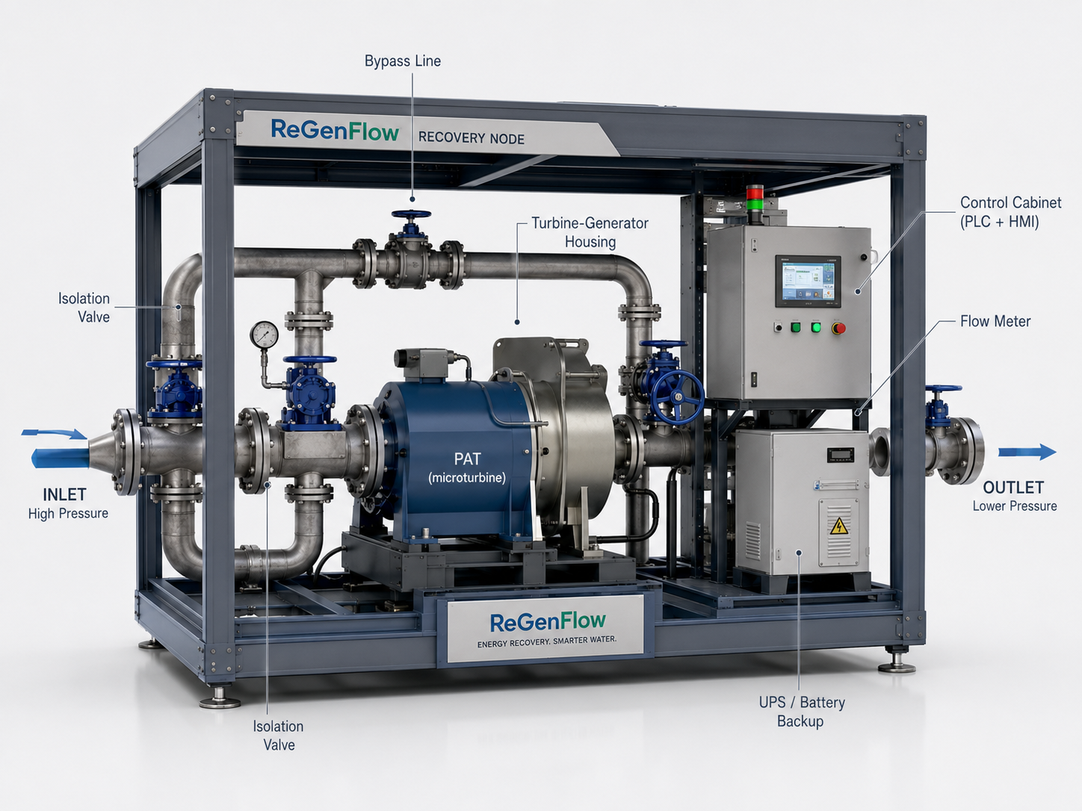
Figure 4. Indicative ReGenFlow Recovery Node concept. The skid converts verified surplus pressure head into electricity while the bypass preserves water service.
Source: Authors' engineering concept render, 2026.

2.3.4 Local Use, Storage, and Federated Dispatch
The three facilities do not exchange electricity through one citywide cable. Each Recovery Node uses or stores electricity behind its own facility meter. ReGenCity OS receives a digital flexibility envelope that states available power, duration, storage state of charge, expected operations, safety reserve, and owner restrictions. The platform sends a bounded dispatch request, and the local controller accepts or rejects the request according to current site conditions.
The proposed hardware totals about 2.54 MW of bidirectional nameplate power, but nameplate power is not a firm grid product. After availability, state of charge, service limits, and aggregation losses are applied, the pilot targets 1.30 MW for 15 minutes with at least 90 percent successful calls. Direct local use remains the economic foundation. The full storage and flexibility envelope appears in Appendix 4.6.
Figure 5 places the three node types inside one North Jakarta pilot cluster. Solid arrows represent energy that stays inside each facility, while dotted links represent telemetry, verification data, and bounded dispatch requests.
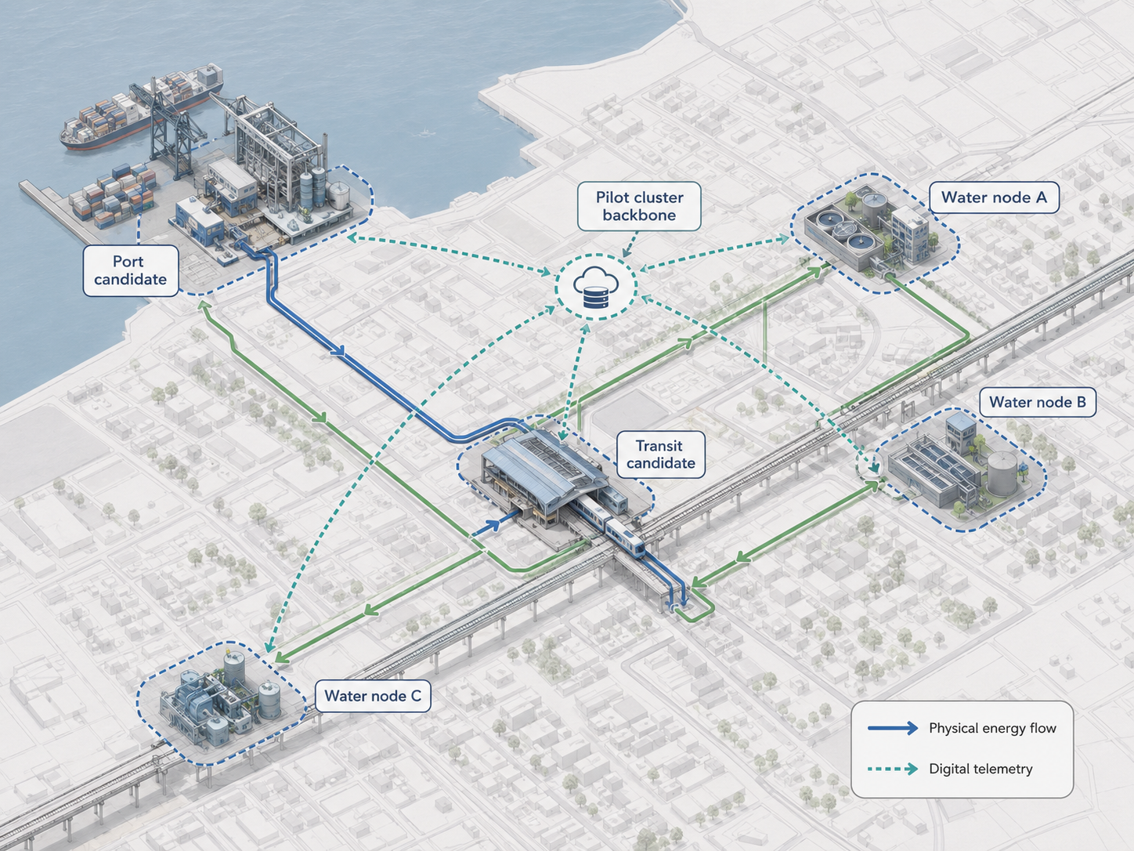
Figure 5. North Jakarta pilot cluster, candidate sites pending gates. The map separates facility-level energy flow from digital telemetry and keeps every site provisional until screening is complete.
Source: Authors' engineering concept render, 2026.

2.4 Internal and External Strategic Analysis
This section tests whether the concept fits its policy, ownership, and delivery environment. The goal is to filter attractive ideas through practical constraints before capital is committed.
The external case supports a measured retrofit, subject to strict limits. Smart-grid policy and Jakarta climate goals support energy efficiency. Fragmented ownership slows approval. Avoided local electricity offers a clearer economic basis than uncontracted grid revenue. Proven components reduce invention risk, while legacy interfaces, public procurement, cybersecurity, and safety approval raise delivery risk. The full PESTEL assessment appears in Appendix 5.1.
ReGenCity offers modular assets, local-use savings, common measurement, and owner veto. The weak points are absent field data, modest energy volume, multi-owner coordination, and uncertain water sites. The strategy therefore favours open interfaces, modular tenders, conservative local savings, and early rejection of weak assets. The SWOT findings appear in Appendix 5.2. The resulting actions appear in Appendix 5.3.
Five gates precede scoring. A candidate must pass safety, public service, owner authority, data adequacy, and technical additionality. Only a passing asset receives an Urban Recoverability Index score for net energy, qualified flexibility, lifecycle economics, carbon displacement, operational compatibility, data readiness, and replication. The gate logic appears in Appendix 5.4. The scoring model appears in Appendix 5.5. Stakeholder roles appear in Appendix 5.6.

2.5 North Jakarta Pilot and Phase-Gated Implementation
This section turns the concept into a pilot plan. The emphasis is staged delivery, measurable checkpoints, and early exit if the evidence weakens.
The 24-month pilot covers one port package, one transit package, three water candidates, and one common digital layer. North Jakarta provides a dense test cluster. Site selection still begins with data agreements, baseline meters, and engineering studies. Months 1 to 6 test opportunity and additionality. Months 5 to 9 complete safety, measurement, cyber, design, and procurement work. Months 10 to 18 cover manufacture, installation, tests, and operator training. Months 18 to 24 cover shadow operation, bounded dispatch, independent verification, and the replication decision. The detailed work plan appears in Appendix 6.1. Figure 6 condenses the phase sequence and gate timing.
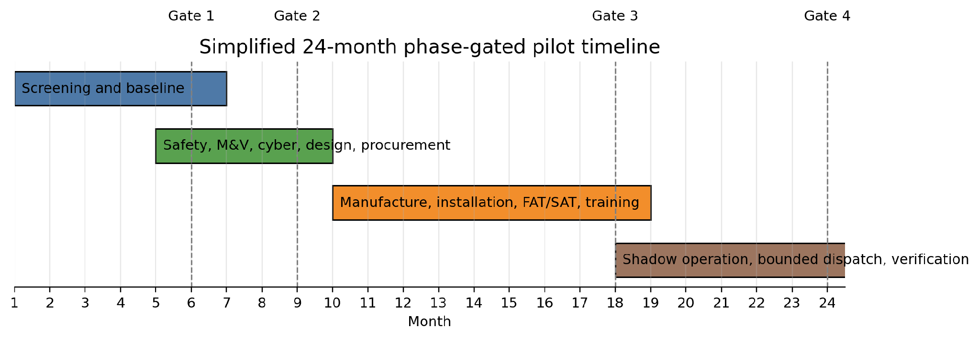
Figure 6. Simplified 24-month phase-gated pilot timeline. The pilot front-loads screening and design discipline, then delays live dispatch until testing and owner sign-off are complete.
Source: Authors' analysis based on the pilot work plan, 2026.
Four gates control spending and operational authority. Gate 1 approves evidence-worthy candidates. Gate 2 approves a safe design within the break-even envelope. Gate 3 approves bounded live operation after factory tests, site tests, failover drills, and owner sign-off. Gate 4 chooses scale, redesign, local-only operation, or closure. The evidence and stop rules appear in Appendix 6.2. The RACI matrix appears in Appendix 6.3.
The pilot records one-second telemetry and reconciles results with 15-minute and monthly feeder data. High-speed traces support commissioning where transient behaviour matters. Advancement requires at least 95 percent valid data, no more than 10 percent uncertainty, at least 0.80 GWh annualized net recovery, at least 1.00 MW for 15 minutes, at least 90 percent call success, and no material service or safety effect. The measurement architecture appears in Appendix 6.4. Baseline equations and adjustment variables appear in Appendix 6.5.

2.6 Economic Sustainability and Ten-Year Financial Projection
This section addresses economic sustainability rather than pure profit. The model asks whether the pilot can recover capital and protect long-run operating value under conservative assumptions.
The economic model relies on avoided electricity purchases. The base plan uses Rp7.00 billion in initial capital, 1.153 GWh in Year 1, 0.5 percent annual degradation, Rp1,200 per kWh in avoided value, Rp0.30 billion in annual operation and maintenance, a Rp0.60 billion overhaul in Year 6, and a 6 percent real discount rate. Grid services, carbon credits, capacity payments, tax benefits, grants, and avoided maintenance are set to zero. Assumptions appear in Appendix 7.1. The planning CAPEX basis appears in Appendix 7.2.
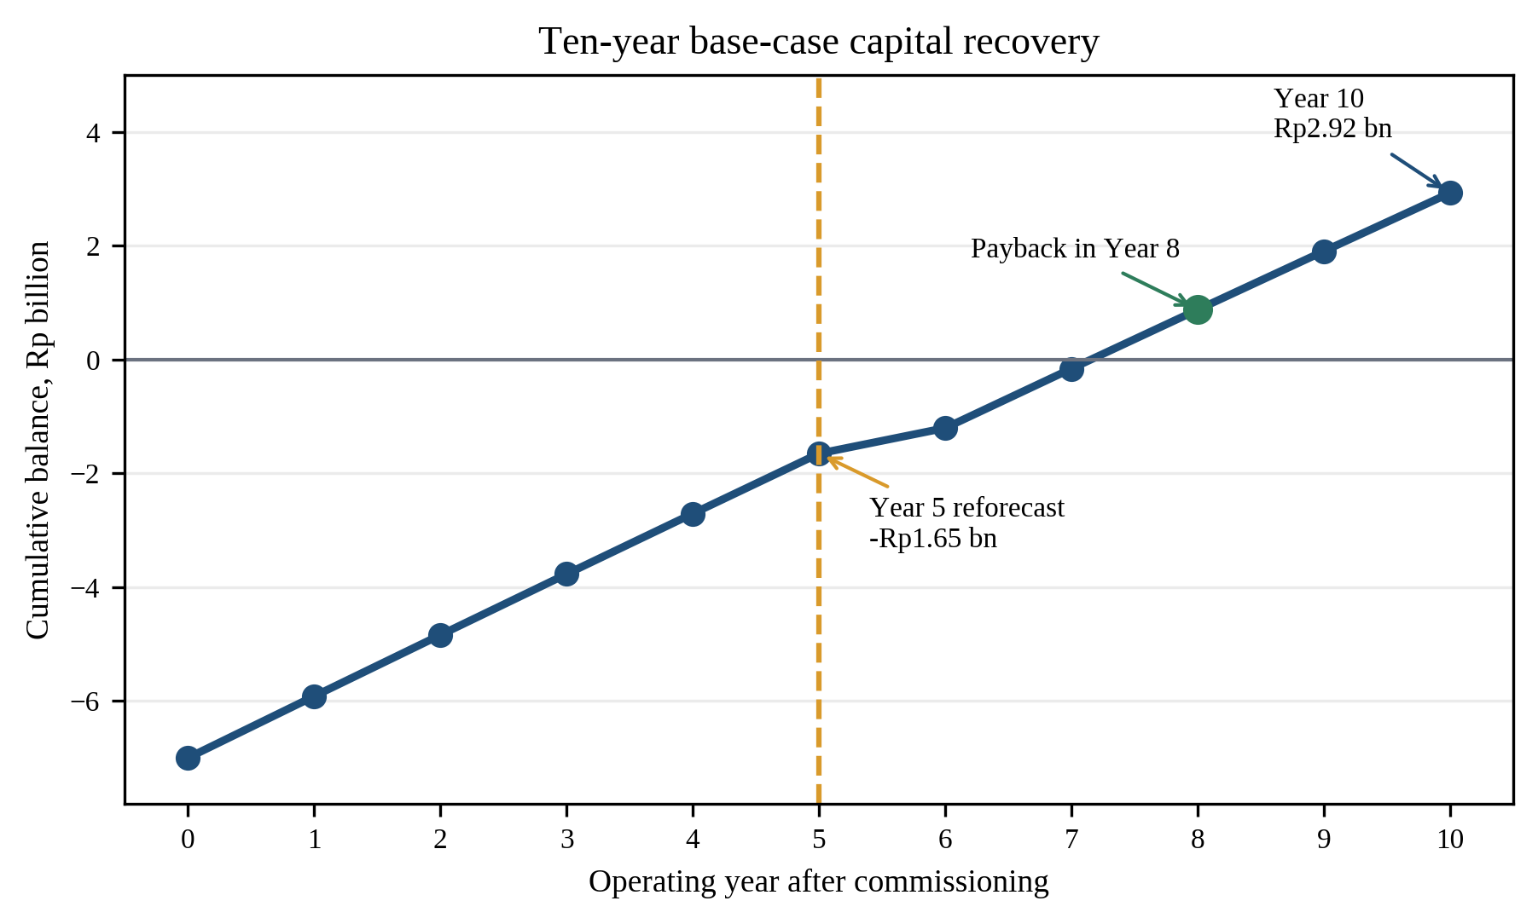
Figure 7. Ten-year base-case capital recovery. The model reaches simple payback in Year 8 and ends Year 10 at Rp2.92 billion.
Source: Authors' analysis based on the base-case financial model, 2026.
The base case reaches simple payback in Year 8. The Year 10 cumulative balance is Rp2.92 billion. Real NPV is Rp0.35 billion, and the levelized cost of recovered electricity is about Rp1,158 per kWh. Break-even requires at least 1.113 GWh per year, at least Rp1,158 per kWh in avoided value, or CAPEX no higher than Rp7.35 billion under the base operating assumptions. The complete cash-flow model appears in Appendix 7.3. Break-even and sensitivity tests appear in Appendix 7.4.
A 20,000-run Monte Carlo test varies the engineering and financial inputs across declared ranges. About 50.6 percent of ungated trials produce nonnegative NPV. Among trials meeting the observable Gate 2 thresholds for recovery, CAPEX, and avoided value, 91.9 percent produce nonnegative NPV. This result is a synthetic decision test, not a field success forecast. The model, distributions, and conditional results appear in Appendix 7.5.

2.7 Quantified Impact, Risk Mitigation, and Evidence-Gated Replication
This section summarizes what the pilot is expected to change if the base case holds. It also shows how the proposal contains risk and limits expansion to evidence-backed cases.
At the 0.87 tCO2 per MWh Java-Madura-Bali operating emissions factor, the base recovery projection avoids about 1.00 ktCO2 per year before embodied emissions. Degradation-adjusted recovery reaches 5.705 GWh over five operating years and 11.270 GWh over ten years. Operational avoidance reaches 4.964 ktCO2 over five years and 9.805 ktCO2 over ten years. Final reporting must separate batteries, converters, civil works, replacement, and end-of-life impacts. The full impact calculation appears in Appendix 7.7. Figure 8 summarizes the five-year and ten-year operational effect.
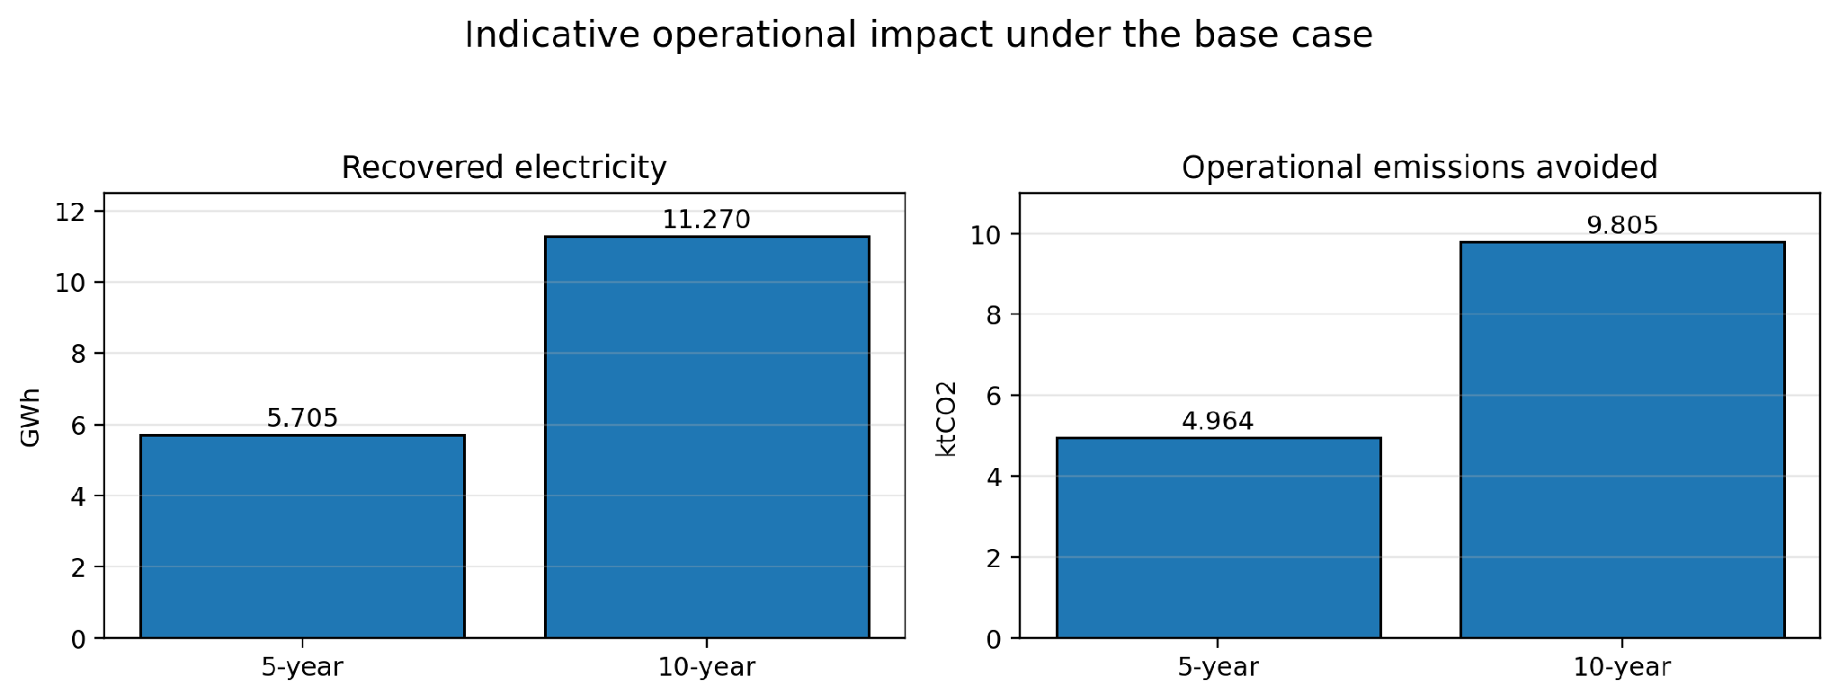
Figure 8. Indicative five-year and ten-year operational impact under the base case. The chart summarizes recovered electricity and avoided operational emissions before embodied impacts are added.
Source: Authors' analysis based on the impact calculation in Appendix 7.7, 2026.
The pilot measures energy, flexibility, data quality, service performance, safety, cybersecurity, economics, operator competence, and replication effort. The causal chain is direct: a measured dissipative event reduces feeder imports, verified availability creates bounded flexibility, and verified net electricity supports an operational emissions claim. The KPI dictionary appears in Appendix 9.1.
Table 2. Principal pilot risks and controls
Risk name | Description | Mitigation
Lower-than-modelled yield | Existing regeneration, low activity, or losses reduce additionality. | Meter first. normalize activity. resize or exclude a weak module before major procurement.
Service and safety interference | Dispatch interference affects cargo, train, or water operations. | Deterministic interlocks, operator veto, staged shadow mode, independent safety sign-off.
Unauthorized dispatch | A compromised command crosses operational boundaries. | Network segmentation, allow-listed commands, signed logs, least privilege, safe local fallback.
Governance or data delay | Unclear authority or rights stall decisions and verification. | Data-sharing agreements, asset-owner control, city gate board, independent verifier.
Economic shortfall | CAPEX, tariff value, or O&M moves NPV below zero. | Open modular tenders, Rp7.35 bn award ceiling, Year-5 reforecast, optional upside kept separate.
Risk controls affect design and gate decisions. Metering addresses low yield. Local interlocks and owner veto protect service. Network segmentation and signed logs constrain dispatch. Modular tenders and the Rp7.35 billion award ceiling protect economics. The risk method and heatmaps appear in Appendix 8.1. The full risk register appears in Appendix 8.2.
Replication follows evidence. Wider Jakarta receives only modules passing service, measurement, cyber, and economic gates. Other cities enter screening after pilot coefficients support comparable asset classes. The Month 24 decision matrix appears in Appendix 9.3. The later city-screening method appears in Appendix 9.4. ReGenCity therefore offers a measured efficiency layer and short-duration flexibility. The proposal does not replace renewable generation, long-duration storage, or grid reinforcement.

3. CONCLUSION

The energy Indonesian cities already discard through cranes, trains, and water mains is a gravity battery that nobody has switched on, held off not by any missing technology but by the absence of a shared protocol, and ReGenCity Grid Indonesia supplies exactly that protocol, a phase-gated retrofit and verification standard that turns Recovery Nodes already documented in the engineering literature into one measurable system, projects a conservative 1.153 GWh and roughly 1.00 ktCO2 avoided each year, guards that projection with gates built to reject a weak module before it is ever funded, and carries what survives those gates from a first test in North Jakarta into wider Jakarta and eventually into other Indonesian cities, each screened on its own evidence rather than assumed capable because it resembles Jakarta.

REFERENCES
Adham, M., Keene, S., & Bass, R. B. (2025). Distributed energy resources: A systematic literature review. Energy Reports, 13, 1980–1999. https://doi.org/10.1016/j.egyr.2025.01.026
Alasali, F., Haben, S., Holderbaum, W., & Potter, B. (2019). Energy management systems for a network of electrified cranes with energy storage. Energies, 12(9), 1771. https://doi.org/10.3390/en12091771
Cai, K., Han, Y., Xia, R., Wu, J., Wang, J., & Lund, P. D. (2024). Gravity energy storage: A review on system types, techno-economic assessment and integration with renewable energy. WIREs Energy and Environment, 13(6), Article e543. https://doi.org/10.1002/wene.543
Darmawan, M., & Kurniawan, R. (2023). Analysis of regenerative braking energy on urban rail operation. Jurnal Konversi Energi dan Manufaktur, 8(2). https://doi.org/10.21009/jkem.8.2.4
Efficiency Valuation Organization. (2022). International Performance Measurement and Verification Protocol: Core concepts. https://evo-world.org/en/products-services-mainmenu-en/protocols/ipmvp
González-Gil, A., Palacin, R., & Batty, P. (2013). Sustainable urban rail systems: Strategies and technologies for optimal management of regenerative braking energy. Energy Conversion and Management, 75, 374–388. https://doi.org/10.1016/j.enconman.2013.06.039
González-Gil, A., Palacin, R., Batty, P., & Powell, J. P. (2014). A systems approach to reduce urban rail energy consumption. Energy Conversion and Management, 80, 509–524. https://doi.org/10.1016/j.enconman.2014.01.060
Institute of Electrical and Electronics Engineers. (2016). IEEE standard for ubiquitous green community control network protocol (IEEE 1887-2014). https://standards.ieee.org/ieee/1887/5627/
International Energy Agency. (2021). E4 country profile: Energy efficiency Indonesia. https://www.iea.org/articles/e4-country-profile-energy-efficiency-indonesia
International Energy Agency. (2024). Empowering urban energy transitions: Smart cities and smart grids. https://www.iea.org/reports/empowering-urban-energy-transitions
International Energy Agency. (2025). Electricity 2025: Analysis and forecast to 2027. https://www.iea.org/reports/electricity-2025
International Energy Agency. (2025b). Energy Efficiency 2025. https://www.iea.org/reports/energy-efficiency-2025
International Organization for Standardization. (2014). ISO 50015:2014: Energy management systems—Measurement and verification of energy performance of organizations. https://www.iso.org/standard/60043.html
Jakarta International Container Terminal. (n.d.). Company and terminal information. https://www.jict.co.id/article/59
Jakarta Provincial Government. (n.d.). Efforts to reduce greenhouse-gas effects in Jakarta. https://www.jakarta.go.id/page/upaya-menurunkan-efek-gas-rumah-kaca-grk
Kramer, M., Terheiden, K., & Wieprecht, S. (2018). Pumps as turbines for efficient energy recovery in water supply networks. Renewable Energy, 122, 17–25. https://doi.org/10.1016/j.renene.2018.01.053
LRT Jakarta. (2024). Service schedule and tariff information. https://ww.lrtjakarta.co.id/menemani_perjalananmu_lrt_jakarta_tawarkan_tarif_khusus_rp_untuk_semua_rute_berita650.html
Ministry of Energy and Mineral Resources of the Republic of Indonesia. (2021). Decree No. 163.K/HK.02/MEM.S/2021 on electricity-system greenhouse-gas emission factors. https://jdih.esdm.go.id/common/dokumen-external/Kepmen%20ESDM%20No.%20163.K_HK.02-MEM.S-2021.pdf
Ministry of Energy and Mineral Resources of the Republic of Indonesia. (2024). Regulation No. 7 of 2024 on electricity tariffs. https://jdih.esdm.go.id/common/dokumen-external/Permen%20ESDM%20Nomor%207%20Tahun%202024.pdf
Ministry of Energy and Mineral Resources of the Republic of Indonesia. (2025). Regulation No. 10 of 2025. https://jdih.esdm.go.id/dokumen/download?id=2025pmesdm10.pdf
Muhammetoglu, A., Karadirek, I. E., Ozen, O., & Muhammetoglu, H. (2018). Full-scale PAT application for energy production and pressure reduction in a water distribution network. Water Supply, 18(4), 1302–1312. https://doi.org/10.2166/ws.2017.087
National Institute of Standards and Technology. (2023). Guide to operational technology security (NIST SP 800-82 Rev. 3). https://csrc.nist.gov/pubs/sp/800/82/r3/final
National Institute of Standards and Technology. (2024). The NIST Cybersecurity Framework (CSF) 2.0 (NIST CSWP 29). https://doi.org/10.6028/NIST.CSWP.29
New York State Energy Research and Development Authority. (2023). Subway system energy usage and electrical storage system applications analysis (Report 23-19). https://www.nyserda.ny.gov/-/media/Project/Nyserda/Files/Publications/Research/Transportation/23-19-Subway-System-Energy-Usage-and-Electrical-Storage-System-Applications-Analysis-acc.pdf
PAM Jaya. (2024). Annual report 2023. https://ppid.pamjaya.co.id/
Souza, D. E. S. e, Mesquita, A. L. A., & Blanco, C. J. C. (2021). Pump-as-turbine for energy recovery in municipal water supply networks: A review. Journal of the Brazilian Society of Mechanical Sciences and Engineering, 43, Article 489. https://doi.org/10.1007/s40430-021-03213-z
Tran, T. V., Chabanon, C., & Masson, P. (2008). Wayside energy-storage systems for rail-transit regenerative braking. In 43rd International Universities Power Engineering Conference. https://doi.org/10.1109/UPEC.2008.4651655
Zhao, N., Schofield, N., Niu, W., Suntharalingam, P., & Zhang, Y. (2014). Hybrid power-train for port crane energy recovery. In 2014 IEEE Conference and Expo Transportation Electrification Asia-Pacific (ITEC Asia-Pacific) (pp. 1–6). IEEE. https://doi.org/10.1109/ITEC-AP.2014.6941043

APPENDICES
Appendix dossier map. Appendices 1-2 preserve competition placeholders for the team. Appendices 3-9 provide the evidence, calculations, implementation controls, economics, risk analysis, and replication logic supporting Sections 2.1-2.7. Every number is labelled as a published fact, planning assumption, derived projection, pilot target, or future measured result.
Appendix dossier navigation
Appendix | Contents | Main-text link
1 | Statement of Originality
2 | Personal Biodata
3 | Evidence, Prior Art, and Claim-Assumption Register | 2.1-2.2
4 | Engineering Model and Anchor Calculations | 2.1-2.3
5 | Asset Selection and Strategic Fit | 2.4
6 | Pilot Delivery, Governance, and Measurement | 2.5
7 | Economics and Quantified Impact | 2.6-2.7
8 | Risk and Controls | 2.7
9 | KPI Dictionary and Evidence-Gated Replication | 2.7

Appendix 1. Statement of Originality


Appendix 2. Personal Biodata
Complete one biodata form for every team member. Retain all placeholders until the team enters final data.

Author 1
A. Personal Identity
No. | Field | Team entry
1 | Full Name | David Muhammad Thorique
2 | Student ID Number | 2506536774
3 | Study Program/Major | Public Administration
4 | Place and Birth Date | Bogor, July 18, 2006
5 | Address | Depok
6 | E-mail | davidmt901@gmail.com
7 | Phone Number | 089517788494
B. Writing Award During University
No. | Type of Award | Awarding Institution | Title of Work | Year
1 | - | - | - | -
2 | - | - | - | -

Author 2
A. Personal Identity
No. | Field
1 | Fauzi Fadhlurrohamn
2 | 2406406080
3 | English Literature
4 | Bekasi, 3 Juli 2006
5 | Perumahan Mekarsari Permai Blok B5 No. 73 RT 05 / RW 09, Kel. Mekarsari, Kec. Tambun Selatan, Kab. Bekasi - 17510
6 | fauzifafa06@gmail.com
7 | 0895402293457
B. Writing Award During University
No. | Type of Award | Awarding Institution | Title of Work | Year
1 | 1st Winner - Trisakti Marketing Crown Business Case Competition 2026 | Trisakti Marketing Club | Aqua Reloop+ Strategi Terintegrasi untuk Meningatkan Pengembalian Botol AQUA | 2026
2 | 1st Place Winner - UNLIMITED international Essay Competition | Himpunan Mahasiswa Elektro Universitas Diponegoro | From pixels to planet: Climify in improving climate literacy through gamified asynchronous collaboration to achieve SDGs 2030 | 2026
3 | 2nd Place Winner - OIM FIB UI 2025: PKM-RSH | BEM FIB Universitas Indonesia | FACTORS INFLUENCING PRO-ENVIRONMENTAL BEHAVIOR: A CASE STUDY OF STUDENT PARTICIPATION IN THE FTUI PLASTIC BOTTLE DROPBOX PROGRAM | 2025
4 | 1st Place Winner - ASTRAtech Innovation Showcase 2025: Business Case Competition | ASTRA Polytechnic | The SYNC Strategy: Mengintegrasikan Sistem, Menguatkan Engagement, dan Membangun Strategi Digital melalui SIA 2.0 | 2025
5 | 2nd Winner of Business Model Canvas Competition | Himpunan Mahasiswa Sosial Ekonomi Pertanian Universitas Bengkulu | C&F Living Aroma Diffuser: Transformasi Limbah Kopi dan Buah menjadi inovasi aromaterapi berkelanjutan | 2025
6 | Idea Champion 2.0: National Innovation & Solution Competition for Students | Culture & Learning Center UII | Gotong Pangan: A Decentralized Circular Economy Model that  integrates BSF technology and community-based initiatives to  transform food waste into economic opportunity and accelerate  the SDGs | 2025
7 | 1st Winner - Insightnovation National Essay Competition, ESCAPE UI 2025 | UI Achievement Community | GOTONG SAMPAH: INOVASI SOCIO-ENTERPRISE INKLUSIF GUNA MENINGKATKAN NILAI EKONOMI LIMBAH DAN FORMALISASI PROFESI PEMULUNG SEBAGAI AKSELERATOR INDONESIA EMAS 2045 | 2025
8 | 2nd Place Winner - Young Entrepreneur Business Plan Competition 2025 | HIPMI PT Universitas Diponegoro | Algea: Skincare Berkelanjutan dengan sentuhan alami dan warisan nusantara | 2025
9 | 2nd Place Winner - Business Plan Competition Vol. 2 2025 | Himpunan Mahasiswa Manajemen Universitas Gunadarma | FEEDIFY KIT: Inovasi DIY Kit Budidaya Larva BSF Berbasis Ekonomi Sirkular sebagai Langkah mewujudkan SGs 2030 | 2025
10 | 3rd Place Winner - Nutrition Expo Essay Competition 2025 | FKM Universitas Indonesia | MAMAM-MANIA: PENDEKATAN BOTTOM-UP DALAM DESAIN MENU MBG MELALUI KARTU BERBASIS ETNOGRAFI TERGAMIFIKASI GUNA MENINGKATKAN PEMANFAATAN PROTEIN LOKAL DI DAERAH 3T | 2025
11 | 3rd Place Winner - Finvation National Essay Competition 2025 | Himpunan Mahasiswa D3 Akuntansi Universitas Airlangga | CATERFLOW: INOVASI APLIKASI PEMBERDAYAAN UMKM CATERING SEBAGAI PENGGERAK OPTIMALISASI LOGISTIK BISNIS DI ERA SOCIETY 5.0 | 2025
12 | 5th Place - WriteYuk National Essay Competition 2025 | WriteYuk | LIMBAH2PAKAN: PROGRAM INOVASI SOSIAL BERKELANJUTAN MELALUI DIY KIT BUDIDAYA LARVA BSF GUNA MENGELOLA FLW SEBAGAI LANGKAH MEWUJUDKAN SDGS 2030 | 2025

Appendix 3. Evidence, Prior Art, and Claim-Assumption Register

A3.1 Evidence Classification
Return to the related main-text section
The essay deliberately separates five evidence classes. This prevents a calculated scenario from being narrated as a field result and makes later replacement with pilot data straightforward.
Code | Class | Meaning | Example
PF | Published fact | External source with stable citation | Emission factor. published rail study
PA | Planning assumption | Transparent input chosen for screening | Mass, head, conversion efficiency
DP | Derived projection | Formula applied to PF/PA inputs | GWh/year. NPV. avoided emissions
PT | Pilot target | Pass/fail level set before operation | >=0.80 GWh/y. >=95% data validity
MR | Measured result | Independent pilot evidence | Unavailable until commissioning and M&V

A3.2 Prior-Art Boundary and Integration Claim
Return to the related main-text section
Existing field | Established capability | ReGenCity concession | Defensible contribution
Regenerative crane drives / crane energy storage | Recover lowering energy and manage pulses within a terminal. | Not claimed as new. | Common cross-sector node contract, M&V, gates, and federated flexibility.
Rail regenerative braking / wayside storage | Capture energy the traction network cannot simultaneously absorb. | Not claimed as new. | Same verification and dispatch envelope as port and water assets.
Pumps-as-turbines / microturbines | Convert excess pressure head to electricity. | Not claimed as new. | Mandatory hydraulic/service gate plus portfolio-level coordination.
Virtual power plant | Aggregate and dispatch distributed flexibility as a portfolio. | Not claimed as new. | Only additional, metered urban recovery assets enter the portfolio.
Digital twin / AI energy management | Forecast operations and optimize control. | Not claimed as new. | Recovery-aware model, hard local constraints, benchmarked incremental value.
Novelty statement. ReGenCity's contribution is a phase-gated urban retrofit and coordination standard: common Recovery Nodes, service-first screening, a transparent Recoverability Index, one measurement protocol, and federated dispatch of verified short-duration flexibility across different asset owners. Novelty is tested by comparing coordinated operation with independent site control. the pilot hypothesis is at least 5% additional captured energy or peak value.

A3.3 Claim-Assumption Register
Return to the related main-text section
ID | Claim | Class | Current basis | Required validation | Uncertainty
C1 | Base pilot recovery is projected at 1.153 GWh/y. | DP | Three physics models. no field data | Replace with normalized feeder M&V | High
C2 | Qualified portfolio target is 1.3 MW for 15 min. | PT | 2.5 MW nameplate with derating | 10 consecutive call tests | High
C3 | Coordination adds >=5% value. | PT | Hypothesis only | A/B test independent vs coordinated | High
C4 | AI adds >=3% net value. | PT | Hypothesis only | Back-test and shadow-mode comparison | Medium
C5 | Operational emissions fall 1.00 ktCO₂/y. | DP | Base energy × 0.87 t/MWh | Use verified energy and current factor | Medium
C6 | Base NPV is +Rp0.35 bn. | DP | Planning CAPEX/tariff/O&M | Replace with bids, bills, contracts | High
C7 | North Jakarta contains eligible assets. | PA | Cluster logic only | Gate-based site survey | High
C8 | Open interfaces reduce lock-in. | PA/PT | Procurement design intent | Conformance and replacement test | Medium
C9 | Public services are unaffected. | PT | Required operating boundary | Service KPIs and safety sign-off | Critical
C10 | Replicability lowers subsequent cost. | PA | Learning-curve hypothesis | Track cost/module and engineering hours | Medium
Interpretation: "High" uncertainty does not make a claim unusable. The pilot must treat the claim as a decision variable rather than a promised outcome.

A3.4 Source-to-Claim Traceability
Return to the related main-text section
Claim area | Principal source | Permitted inference | Location
Port throughput context | JICT public terminal information | Context only. does not prove eligible descents | 2.3. A4.2
Transit service pattern | LRT Jakarta schedule. public procurement information | Supports stop-frequency screening | 2.3. A4.3
Already-returned braking energy | NYSERDA Report 23-19 | Supports incremental/unabsorbed boundary | 2.3. A4.3
Water-recovery feasibility | Muhammetoglu et al.. Kramer et al. | Supports PAT technical precedent | 2.3. A4.4
M&V method | IPMVP. ISO 50015 | Supports baseline, adjustment, and verification | 2.1. A6.5
Grid emissions factor | ESDM Decree 163/2021 | 0.87 tCO₂/MWh screening factor | 2.7. A7.6
OT cybersecurity | NIST SP 800-82r3. CSF 2.0. ISA/IEC 62443 | Controls architecture and assurance | 2.7. A8.4

Appendix 4. Engineering Model and Anchor Calculations

A4.1 System Boundary and Energy Accounting
Return to the related main-text section
Boundary step | Definition | Accounting control
1. Necessary operation | Cargo lowering, train braking, or pressure regulation would occur without ReGenCity. | Reject cycles created only to produce electricity.
2. Gross physical potential | Potential, kinetic, or hydraulic energy before conversion losses. | A screening ceiling, never the impact claim.
3. Otherwise-dissipated share | Portion not already accepted by adjacent loads, traction network, or hydraulic need. | Measured/validated during baseline.
4. Delivered recovery | Gross × conversion × unabsorbed share × delivery. | Meter at recovery-device output.
5. Net facility saving | Adjusted baseline feeder import - post-retrofit feeder import. | Primary energy KPI. includes auxiliaries/losses.
6. Storage discharge | Time-shifted recovered energy. | Do not count a second time.
7. Qualified flexibility | Power sustained for stated duration and successful call rate. | Separate from annual GWh.
Portfolio equation. E_net = Σ(E_delivered at each Recovery Node) - incremental auxiliary electricity - any induced upstream pumping. The result is cross-checked against activity-normalized feeder imports. The lower defensible result is reported when the two methods diverge beyond the uncertainty tolerance.

A4.2 ReGenPort Screening Calculation
Return to the related main-text section
Per-event model: E = mgh ÷ 3.6×10⁶ × η_drive × f_otherwise-dissipated × η_delivery (kWh). Annual energy multiplies this result by eligible events. "Eligible" excludes lifts with energy already reused by common DC buses or adjacent cranes.
Scenario | Events (m/y) | Mass (t) | Height (m) | Drive eff. | Unabs. | Delivery | GWh/y
Conservative | 0.60m | 25 | 20 | 70% | 35% | 85% | 0.170
Base | 1.00m | 30 | 25 | 75% | 50% | 90% | 0.690
Optimized | 1.50m | 35 | 30 | 80% | 65% | 93% | 2.076
Base worked example. 1,000,000 × 30,000 kg × 9.81 m/s² × 25 m ÷ 3.6×10⁶ × 0.75 × 0.50 × 0.90 = 689,766 kWh/year = 0.690 GWh/year. Metering must determine whether one million events and a 50% unabsorbed fraction are credible for the selected equipment.

A4.3 ReGenTransit Screening Calculation
Return to the related main-text section
Per-stop model: E = ½mv² ÷ 3.6×10⁶ × η_electric-braking × f_otherwise-unabsorbed × η_delivery (kWh). The unabsorbed share is essential because modern rolling stock often returns much of its braking energy to simultaneously accelerating trains.
Scenario | Stops (m/y) | Mass (t) | Speed | Brake eff. | Unabs. | Delivery | GWh/y
Conservative | 0.300m | 65 | 40 | 65% | 20% | 85% | 0.037
Base | 0.383m | 75 | 50 | 70% | 30% | 88% | 0.142
Optimized | 0.500m | 85 | 60 | 75% | 45% | 90% | 0.498
Base worked example. 383,250 stops × ½ × 75,000 kg × (50/3.6 m/s)² ÷ 3.6×10⁶ × 0.70 × 0.30 × 0.88 = 142,314 kWh/year = 0.142 GWh/year. The base stop count is a transparent schedule screen (approximately 1,050 braking arrivals/day), not a claim about metered service.

A4.4 ReGenFlow Screening Calculation
Return to the related main-text section
Hydraulic model: P = 9.81QHη (kW), and E = P × 8,760 × availability × number of nodes. A pressure-retaining bypass, water-quality controls, surge analysis, and safe isolation are mandatory. If pressure is produced by upstream pumping, induced pump energy is subtracted.
Scenario | Nodes | Flow (m3/s) | Head (m) | Eff. | Avail. | kW/node | GWh/y
Conservative | 2 | 0.075 | 10 | 55% | 70% | 4.0 | 0.050
Base | 3 | 0.150 | 15 | 65% | 85% | 14.3 | 0.320
Optimized | 4 | 0.250 | 22 | 72% | 90% | 38.8 | 1.225
Base worked example. 3 × (9.81 × 0.15 m³/s × 15 m × 0.65) kW × 8,760 h × 0.85 = 320,486 kWh/year = 0.320 GWh/year. This is the weakest anchor assumption and remains a no-go unless hydraulic modelling and field pressure data establish genuine surplus head.

A4.5 Scenario Summary and Uncertainty
Return to the related main-text section
Scenario | Port | Transit | Water | Total GWh/y | ktCO₂/y
Conservative | 0.170 | 0.037 | 0.050 | 0.257 | 0.223
Base | 0.690 | 0.142 | 0.320 | 1.153 | 1.003
Optimized | 2.076 | 0.498 | 1.225 | 3.799 | 3.305
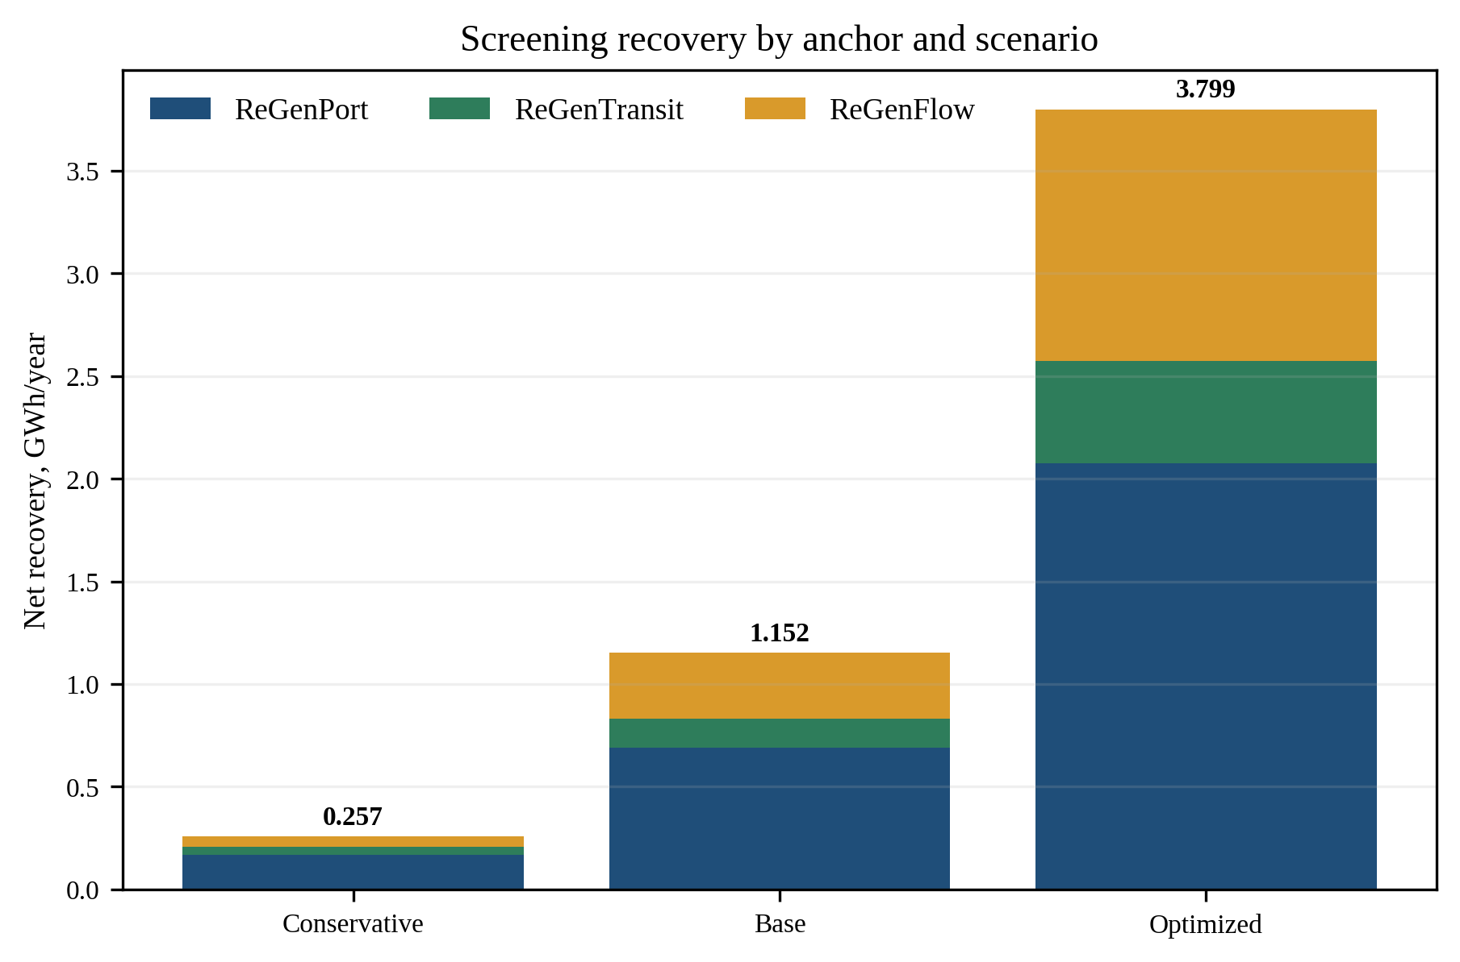
Appendix Figure A4-1. Screening recovery by anchor and scenario. Values are derived projections, not measured output.

A4.6 Storage, Power, and Flexibility Envelope
Return to the related main-text section
Element | Power | Usable duration/energy | Function | Qualification note
Port buffer | 1.50 MW | 0.75 MWh | Absorb crane pulses. support terminal loads | Site study
Transit wayside buffer | 1.00 MW | 0.50 MWh | Absorb unaccepted braking. support station/traction loads | Site study
Water generation | 0.043 MW base | No dedicated storage assumed | Steady local supply | Hydraulic study
Portfolio nameplate | 2.54 MW | 1.25 MWh storage | Not a guaranteed grid product | Do not simply add pulses
Qualified pilot target | 1.30 MW | 15 minutes | Availability/SOC/aggregation derated | >=90% successful calls
Minimum gate | 1.00 MW | 15 minutes | Independent verification | No service or safety effect
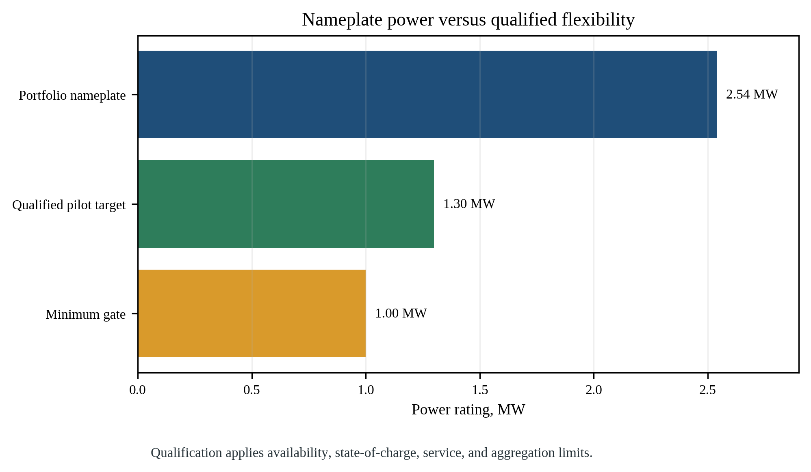
Appendix Figure A4-2. Nameplate power and the derated flexibility thresholds serve different claims.
The flexibility envelope is recalculated before every call from asset availability, predicted operations, storage state of charge, temperature, reserve margins, and owner constraints. ReGenCity OS requests only values inside the envelope. Local controls reject requests when safety or service constraints change.

A4.7 Control Hierarchy and AI Test
Return to the related main-text section
Control level | Purpose | Non-negotiable boundary
Level 0: physical protection | Breakers, pressure protection, braking/crane controls | Deterministic. never bypassed by ReGenCity
Level 1: local Recovery Node | Real-time converter/storage control and safe fallback | Owner-approved limits. works offline
Level 2: site optimizer | Local load matching and peak clipping | Rule-based baseline controller
Level 3: ReGenCity OS | Forecast and federated dispatch recommendation | Receives envelopes, not unrestricted control
Level 4: operator/governance | Veto, emergency stop, permissions, audit | Human accountability retained
AI is optional optimization, not the safety case
AI test | Method | Decision rule
Forecast accuracy | MAE/MAPE against persistence and schedule baseline | Report by asset and operating regime
Energy/peak value | AI vs rule-based A/B or shadow replay | >=3% net improvement target
Constraint compliance | Unsafe/invalid commands | Zero accepted violations
Robustness | Missing data, communications loss, sensor drift | Automatic safe local mode
Explainability | Logged objective, inputs, envelope, reason for action | 100% dispatch traceability
Drift | Performance and residual change | Alert, suspend, retrain, revalidate
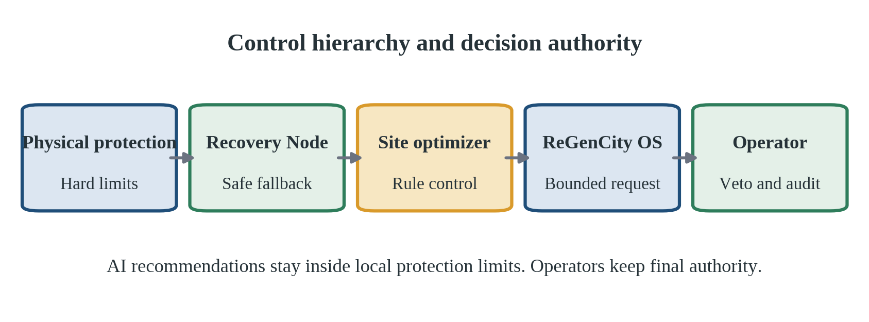
Appendix Figure A4-3. Authority moves from physical protection to human governance without removing local control.

A4.8 Synthetic Digital-Twin and Machine-Learning Validation
Return to the related main-text section
Synthetic data are used only to test software behaviour before live access-not to claim energy or emissions impact. A seeded event generator combines the declared engineering ranges with site schedules to create reproducible port descents, train braking events, water flow/head, facility load, storage state, communications, and fault states. Once field data arrive, the same tests are replayed with measured distributions and all synthetic performance claims are retired.
Synthetic stream | Minimum fields | Stress regimes
Port stream | Timestamp, equipment ID, mass band, descent height/speed, DC-bus acceptance, local load | Normal shifts. simultaneous cranes. low activity. equipment outage
Transit stream | Arrival, vehicle mass band, speed, receptivity, substation load, timetable state | Peak/off-peak. delayed trains. abnormal headway. maintenance
Water stream | Flow, inlet/outlet pressure, bypass state, pump state, quality/service alarms | Peak demand. low head. transient. sensor bias. bypass event
Energy/storage | Power, feeder import, SOC, temperature, availability, conversion losses | Full/empty storage. derating. high temperature. failed meter
Digital/OT | Envelope, command, response, latency, identity, model version, operator veto | Packet loss. stale data. unauthorized command. communications loss
Protocol element | Method | Guardrail
Data split | Chronological: first 60% train, next 20% validate, final 20% blind test | No random leakage from repeated schedules
Champion | Transparent rule-based local controller | Always available safe baseline
Challenger | Forecast + constrained optimizer. model family selected after data audit | No autonomous action outside envelope
Upper bound | Offline perfect-foresight optimization | Diagnostic ceiling, never deployable benchmark
Objectives | Net local recovery value, peak reduction, call reliability | Service/safety constraints are hard, not weighted preferences
Acceptance | >=3% net value vs champion. zero accepted constraint violations. stable under stress | Otherwise retain the champion
Monitoring | Drift, residuals, missingness, latency, out-of-distribution alerts | Suspend challenger and revert automatically
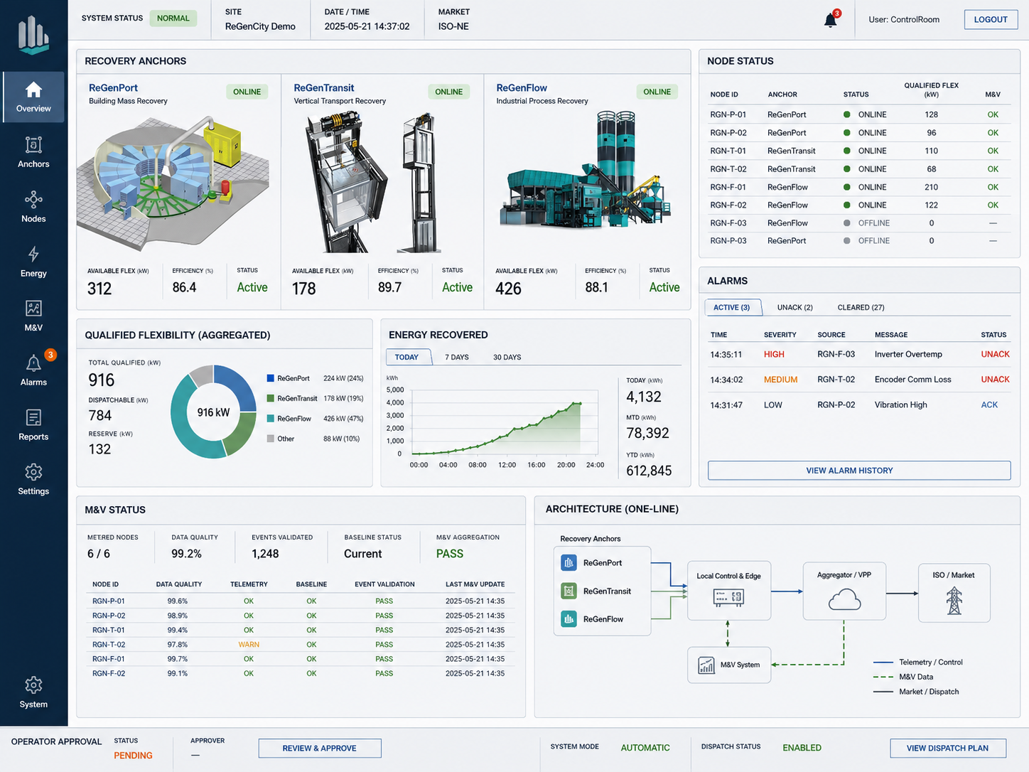
Appendix Figure A4-2. Indicative ReGenCity OS operator interface. The screen keeps node status, M&V quality, alarms, and operator approval visible in one control view.
Source: Authors' engineering concept render, 2026.

Appendix 5. Asset Selection and Strategic Fit

A5.1 PESTEL Analysis
Return to the related main-text section
Factor | Opportunity | Constraint | Strategic response
Political | National smart-grid direction and Jakarta climate commitments favour measured efficiency. | Fragmented authority and leadership changes delay cross-owner decisions. | Inter-agency charter. gate board. owner-level approvals.
Economic | Behind-the-meter savings are available before a grid-service market. | Retrofit CAPEX, tariff variation, and small yields threaten NPV. | Meter-first selection. modular tender. zero VPP revenue in base case.
Social | Efficient public infrastructure builds trust in practical energy transition. | Any perceived threat to water, transport, or jobs will outweigh energy benefits. | Service-first KPIs. operator co-design. transparent incident reporting.
Technology | Regenerative drives, PATs, storage, meters, and digital twins are mature components. | Legacy protocols, harsh sites, data gaps, and integration failure remain. | Open interface profile. conformance tests. offline safe mode.
Environment | Recovery displaces operational imports without additional duty cycles. | Battery/electronics embodied impacts, flood exposure, and end-of-life waste. | Lifecycle procurement, corrosion protection, take-back clauses.
Legal | Energy-efficiency and smart-grid policies establish strategic relevance. | Safety law, public procurement, data protection, and grid participation are separate approvals. | Legal register. staged sandbox. local use before external dispatch.

A5.2 SWOT Matrix
Return to the related main-text section
Quadrant | Decision-relevant findings
Strengths | Modular cross-sector architecture. local-use value. common M&V. portfolio diversification. asset-owner veto.
Weaknesses | No primary data. integration dividend unproven. modest energy quantity. fc multi-owner complexity. weak water-node evidence.
Opportunities | Rising electrification. smart-grid policy. retrofit of legacy infrastructure. open recovery-ready procurement standard.
Threats | Existing regeneration leaves little additionality. cyber/operational incidents. vendor lock-in. CAPEX inflation. unavailable grid-service rules.

A5.3 TOWS Strategy Translation
Return to the related main-text section
Strategy | Action | Concrete instrument
SO | Use modular, verified Recovery Nodes to turn smart-grid policy and existing infrastructure into repeatable efficiency projects. | Common specification + local-use-first economics
ST | Use deterministic local control, M&V, and owner veto to contain cyber, safety, and overclaiming threats. | Safety case + audit trail + independent verifier
WO | Use baseline metering, open tenders, and a staged sandbox to compensate for absent field data and integration uncertainty. | Evidence before equipment. rule-based benchmark
WT | Reject assets failing service or additionality gates. Stop scale-up when CAPEX, yield, or data thresholds fail. | Explicit no-go rules. no cross-subsidy of weak modules

A5.4 Mandatory Gates Before Scoring
Return to the related main-text section
Gate | Domain | Pass question | Minimum evidence | Failure
G-SAF | Safety | Retrofit fails safely and preserves certified protection. | Approved HAZOP/FMEA. owner safety sign-off | Reject
G-SVC | Public/operational service | No unacceptable throughput, schedule, pressure, or quality effect. | Service constraints and test plan | Reject
G-OWN | Owner consent and authority | Owner accepts roles, access, veto, maintenance, and liabilities. | Signed charter/data agreement | Defer/reject
G-DAT | Data adequacy | Baseline variables and feeder data meet validity and uncertainty targets. | Data audit. >=8-week baseline plan | Defer
G-ADD | Technical additionality | A material otherwise-dissipated fraction remains after existing regeneration. | Metering/engineering evidence | Reject
Appendix Figure A5-1. Every mandatory gate must pass before an asset receives a URecI score.

A5.5 Urban Recoverability Index (URecI)
Return to the related main-text section
URecI is calculated only after all mandatory gates pass. Each criterion is scored 0-5 using evidence bands defined before assessment. The weighted score is Σ(weight × score/5), yielding 0-100. A sensitivity check varies each weight by ±20%. an asset is not prioritized if its rank is unstable or if a single high-uncertainty assumption drives the result.
Criterion | Weight | Metric | Indicative scoring anchor
Net annual recovery | 20% | Normalized net kWh after all losses | 0: <50 MWh. 3: 150-300. 5: >500
Qualified flexibility | 15% | Sustained verified kW × duration × reliability | 0: none. 3: useful site peak. 5: portfolio-grade
Lifecycle economics | 20% | NPV/LCRE using common assumptions | 0: deeply negative. 3: near break-even. 5: robust positive
Carbon displacement | 10% | Verified MWh × current official factor | Score relative to candidate set
Operational compatibility | 15% | Disruption, maintainability, outage need | 5: no planned service impact
Data and integration readiness | 10% | Metering, interfaces, ownership, cyber | 5: standards-ready and auditable
Replicability | 10% | Comparable assets, procurement reuse, workforce | 5: many similar eligible sites
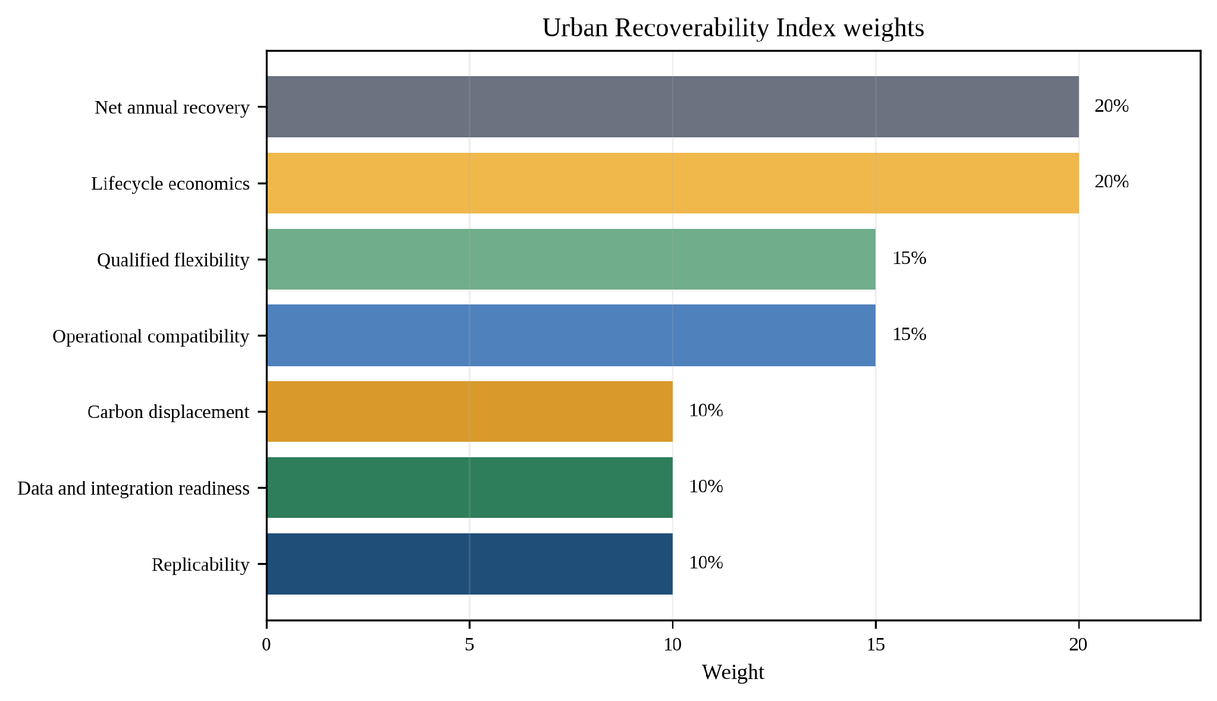
Appendix Figure A5-2. URecI weights balance energy, economics, service, data, and replication.
No candidate is pre-ranked without measurements
Screening unit | URecI score | Current status | Next evidence
Port candidate P-01 | Unknown | Candidate only | Baseline + regenerative-drive audit
Transit candidate T-01 | Unknown | Candidate only | Substation acceptance and braking trace
Water candidates W-01-W-03 | Unknown | Candidate only | 12-month SCADA where available. pressure/flow survey

A5.6 Stakeholder Map
Return to the related main-text section
Stakeholder | Primary role/value | Decision boundary | Engagement
City program office | Common standard, gates, reporting, replication | Cannot override asset safety | Program director / gate chair
Port asset owner/operator | Equipment access, safe operation, local savings | Throughput and equipment safety | Owner engineer + operations lead
Transit owner/operator | Traction/station access, timetable, safety case | Service and rail safety | Chief engineer / operations control
Water utility | Hydraulic data, pressure/quality, maintenance | Water service and public health | Network operations lead
Electric utility/regulator | Interconnection and future grid services | Grid code and tariff pathway | Formal consultation
System integrator | Interface implementation and testing | No unilateral operational authority | Contracted delivery lead
Independent verifier | Baseline, M&V, flexibility, carbon audit | Organizational independence | Direct report to gate board
Emergency/cyber teams | Incident readiness and assurance | Authority to isolate the system immediately | Named escalation contacts
Community and public users receive a public dashboard summary. Service reliability and environmental protection remain mandatory.

Appendix 6. Pilot Delivery, Governance, and Measurement

A6.1 Twenty-Four-Month Phase Logic
Return to the related main-text section
Phase | Timing | Core outputs | Decision
Phase A: Prove the opportunity | M1-M6 | Charter, data rights, baseline, gates, feasibility | Gate 1: evidence-worthy candidates
Phase B: Establish safety and procurement readiness | M5-M9 | M&V design, HAZOP/FMEA, detailed design, tenders, sandbox | Gate 2: approved, affordable design
Phase C: Install and commission | M10-M18 | Factory/site tests, staged installation, integration, training | Gate 3: bounded live authority
Phase D: Verify and decide | M18-M24 | Shadow/live trial, independent M&V, cyber audit, replication package | Gate 4: scale, redesign, or stop
Detailed Gantt, Months 1 to 12
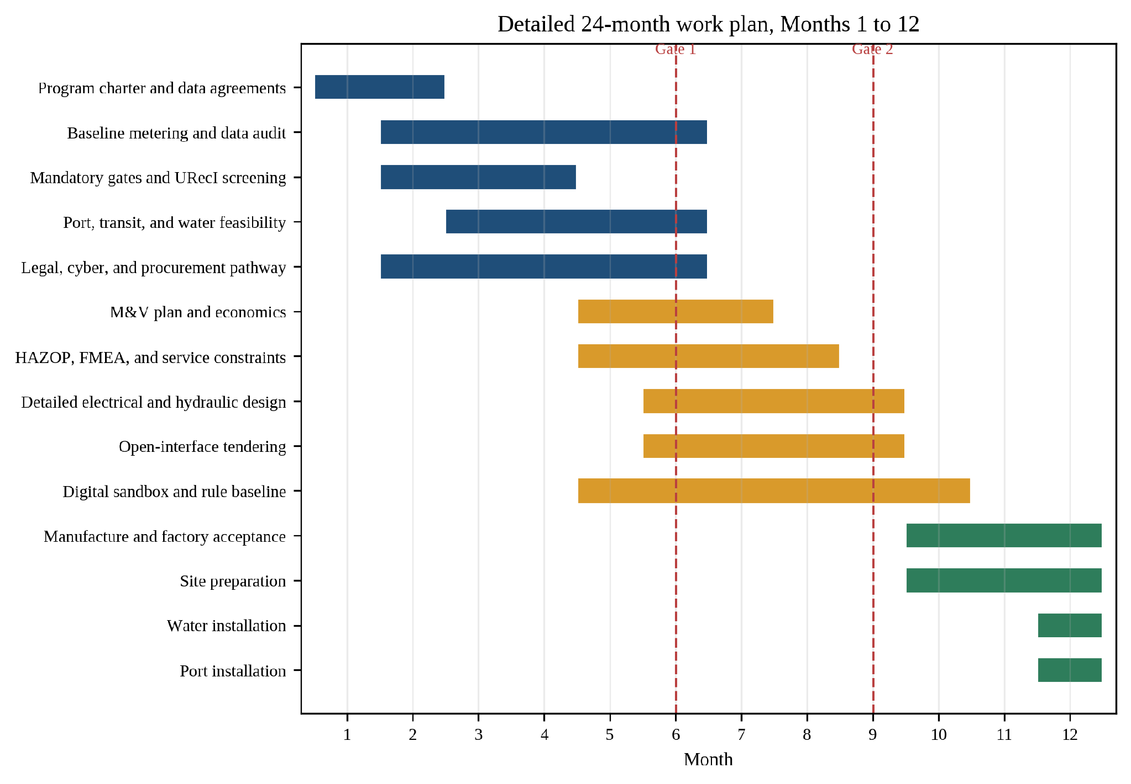
Appendix Figure A6-1. Detailed work plan for Months 1 to 12. Red lines mark decision gates.
Detailed Gantt, Months 13 to 24
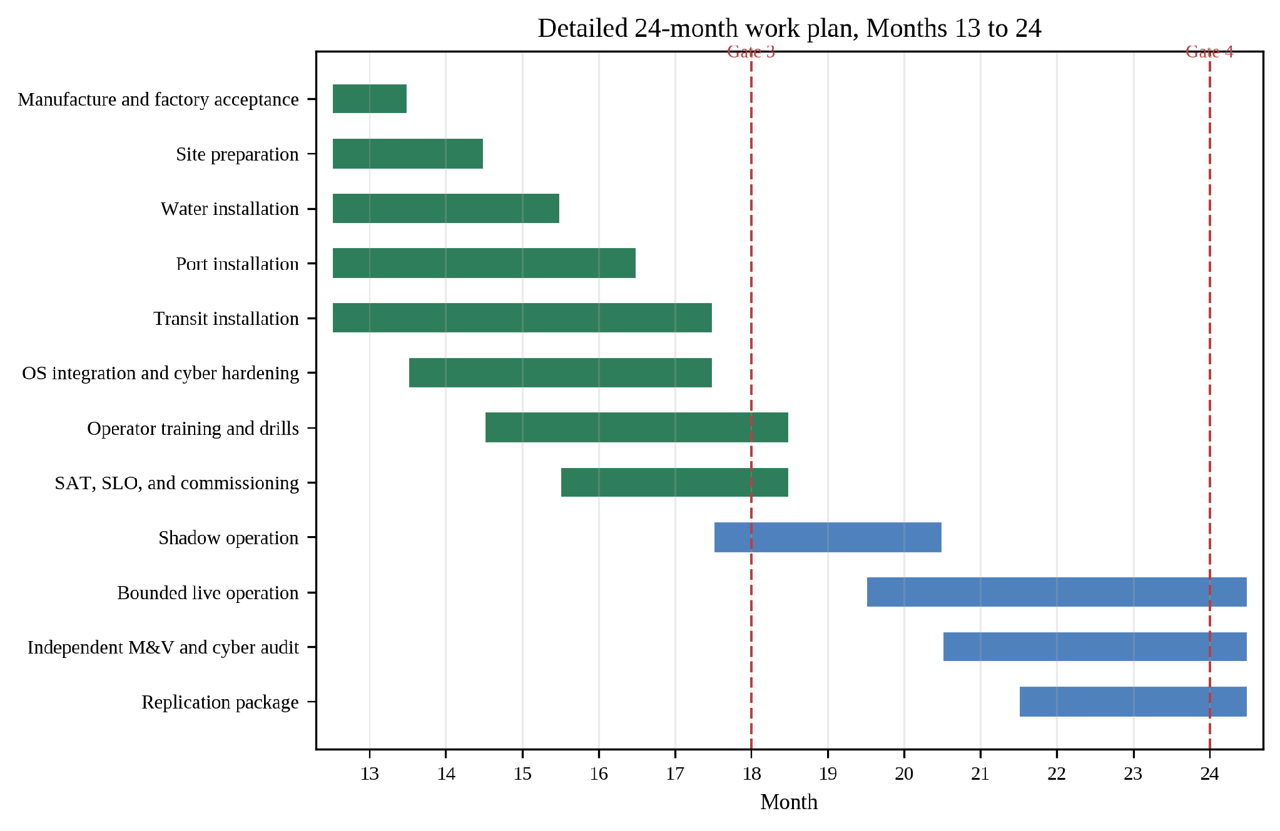
Appendix Figure A6-2. Detailed work plan for Months 13 to 24. Red lines mark decision gates.
All installations are staggered. Live dispatch begins only after Gate 3 at Month 18.

A6.2 Gate Evidence and Stop Rules
Return to the related main-text section
Gate | Minimum evidence | Permitted decision | Authority
Gate 1 - M6 | Data agreements. >=8-week usable baseline plan/data. site feasibility. pass mandatory gates. preliminary additionality | Advance selected candidates. extend metering. or reject | City + owners + verifier
Gate 2 - M9 | Approved safety/service cases. design. M&V plan. cyber model. bids within break-even envelope. permits pathway | Procure modules. redesign. reduce scope. or stop | Gate board
Gate 3 - M18 | FAT/SAT. interlocks. manual override. failover. drills. operator competence. no service effect | Bounded live trial or remain in shadow mode | Asset owners sign individually
Gate 4 - M24 | Independent energy/flexibility results. uncertainty. incidents. final economics. replication stability | Scale selected modules, redesign, or close | City + owners + verifier

A6.3 RACI Matrix
Return to the related main-text section
R = Responsible. A = Accountable. C = Consulted. I = Informed. AO = asset owner. PO = city program office. SI = system integrator. IV = independent verifier. UT = utility/regulator.
Decision/activity | AO | PO | SI | IV | UT
Program charter / gates | C | A/R | I | C | C
Baseline data and site access | A/R | C | I | C | I
Safety and service case | A/R | C | C | C | I
Technical design/integration | A | C | R | C | C
Procurement | A/R | C | C | I | I
M&V plan and audit | C | A | C | R | I
Live dispatch authority | A | C | R within envelope | I | C
Incident response | A/R | C | C | I | I
Replication decision | C | A/R | I | C | C

A6.4 Measurement Architecture and Data Quality
Return to the related main-text section
Data layer | Resolution/window | Purpose | Control
Commissioning traces | 10-100 Hz where transient behaviour matters | Pulse capture, control tuning, conversion losses | Temporary high-speed logger + synchronized meter
Permanent operational telemetry | 1 second | Power, state of charge, status, Q/H, service variables | Recovery Node historian. signed timestamps
Billing reconciliation | 15 minutes and monthly | Net feeder import and economic value | Revenue-grade meter / utility bill
Baseline window | >=8 weeks. preferably 90 days | Activity-normalized pre-retrofit model | Extend when seasonality is material
Water historical context | Available 12-month SCADA preferred | Flow/head seasonality and pressure constraints | Never infer head from nameplate alone
Data-validity target | >=95% | Completeness after defined exclusions | Missingness by variable and operating regime
Uncertainty target | <=10% at portfolio annual result | Confidence in claimed net recovery | Independent calculation and reconciliation

A6.5 M&V Equations and Adjustment Variables
Return to the related main-text section
Anchor | Baseline model | Routine/non-routine adjustment | Claim rule
Port | Baseline feeder kWh = f(eligible moves, mass, height, crane mix, operating hours) | Same variables post-retrofit. weather if material | Net feeder reduction + device meter cross-check
Transit | Substation/station kWh = f(stops, service km, speed profile, train mass, timetable) | Maintenance and service disruptions | Exclude braking already accepted by traction line
Water | Facility kWh and pressure loss = f(Q, H, pump status, hours, pressure setpoint) | Season, demand zone, upstream pumping | Net turbine output - induced pumping/auxiliaries
Portfolio | Sum independently verified site savings | Availability and common-clock alignment | No storage re-count. report covariance/uncertainty
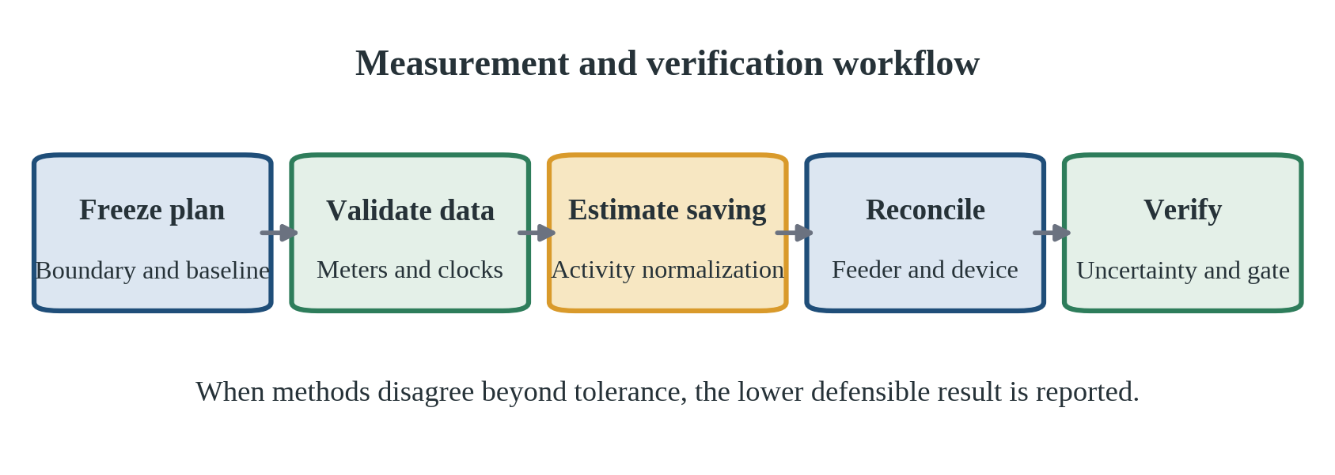
Appendix Figure A6-3. Independent measurement converts device output into an auditable facility result.
Independent verification workflow: freeze the M&V plan before live operation. validate meter calibration and time synchronization. document exclusions. fit and test the baseline. calculate site-level savings. reconcile against device meters. propagate uncertainty. audit dispatch tests. and publish both positive and negative results. Changes after seeing results require a versioned justification and parallel reporting under the original method.

Appendix 7. Economics and Quantified Impact

A7.1 Economic Boundary and Assumptions
Return to the related main-text section
Model purpose. This infrastructure-sustainability screen tests whether verified behind-the-meter electricity savings support the incremental retrofit over ten operating years. The base case excludes VPP revenue, carbon credits, capacity payments, peak-demand charges, tax benefits, grants, and avoided maintenance. Positive values therefore depend on energy recovery and disciplined procurement rather than speculative revenue.
Input | Base value | Class | Treatment
Currency basis | Constant 2026 rupiah | PA | Avoids mixing inflation with real discounting
CAPEX | Rp7.00 bn | PA | Modular proof pilot. replace with Gate 2 bids
Year-1 recovery | 1.153 GWh | DP | Base engineering screen
Annual degradation | 0.5% | PA | Sensitivity/maintenance planning assumption
Avoided electricity value | Rp1,200/kWh | PA | Replace with applicable facility bills/contracts
Annual O&M | Rp0.30 bn | PA | Metering, software, inspections, parts, assurance
Major overhaul | Rp0.60 bn in Year 6 | PA | Power electronics/storage allowance
Real discount rate | 6% | PA | Decision parameter. 4% and 10% tested
Other revenue | Rp0 | Conservative boundary | Grid/carbon upside excluded
Tax/salvage | Rp0 | Conservative boundary | No terminal salvage assumed

A7.2 Planning CAPEX Basis
Return to the related main-text section
Package | Rp bn | Scope note
Port recovery interface and buffer | 1.70 | Converter/storage integration, metering, local controls
Transit wayside interface and buffer | 2.00 | Wayside storage/converter and substation interface
Water recovery modules | 0.80 | Three screened nodes. subject to hydraulic gate
ReGenCity OS, meters, communications, cyber | 1.00 | Common platform and site gateways
Engineering, M&V, assurance, training | 0.70 | Design, safety/cyber review, verifier, operators
Contingency | 0.80 | 11.4% of total. not a substitute for bids
Total | 7.00 | Planning envelope
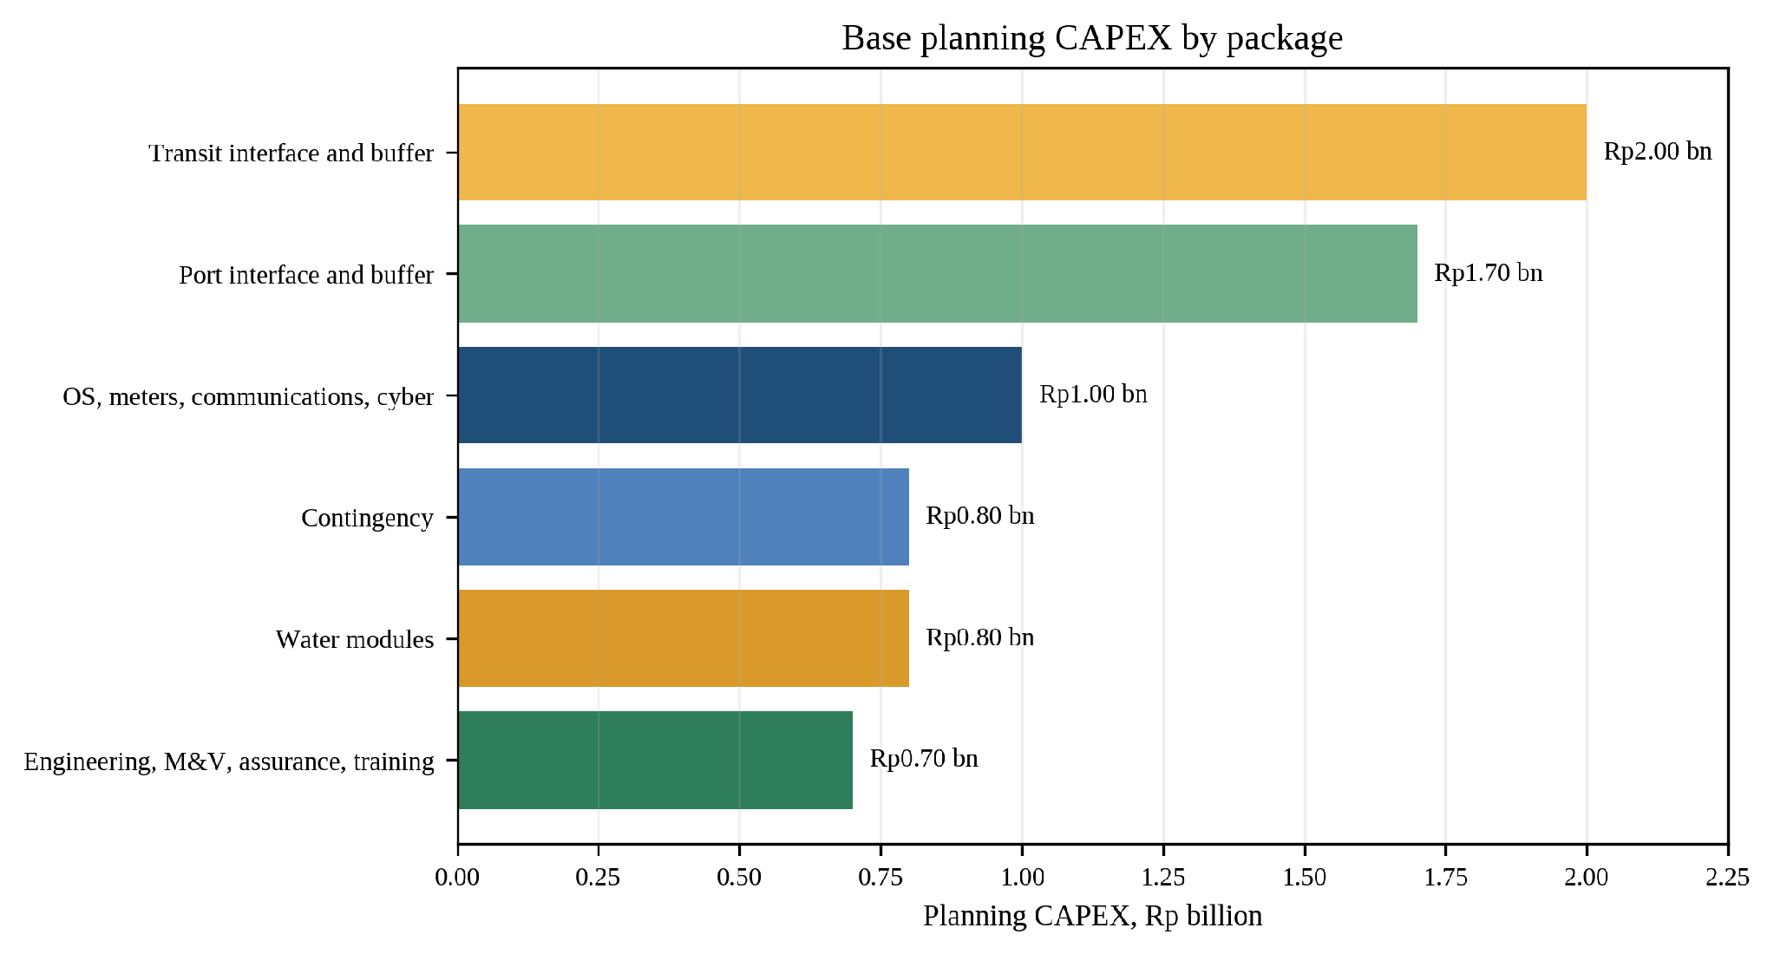
Appendix Figure A7-1. Planning CAPEX by package. Values are assumptions until Gate 2 bids replace them.
The package values are transparent planning assumptions, not quotations. Gate 2 rejects or resizes the package if firm prices move the ten-year case outside the agreed break-even envelope.

A7.3 Full Ten-Year Base Projection
Return to the related main-text section
Rp billion except energy. undiscounted cash balances
Year | GWh | Gross value | O&M | Overhaul | Net | Cumulative
1 | 1.153 | 1.383 | 0.300 | 0.000 | 1.083 | -5.917
2 | 1.147 | 1.376 | 0.300 | 0.000 | 1.076 | -4.841
3 | 1.141 | 1.369 | 0.300 | 0.000 | 1.069 | -3.771
4 | 1.135 | 1.362 | 0.300 | 0.000 | 1.062 | -2.709
5 | 1.130 | 1.356 | 0.300 | 0.000 | 1.056 | -1.653
6 | 1.124 | 1.349 | 0.300 | 0.600 | 0.449 | -1.205
7 | 1.118 | 1.342 | 0.300 | 0.000 | 1.042 | -0.162
8 | 1.113 | 1.335 | 0.300 | 0.000 | 1.035 | 0.873
9 | 1.107 | 1.329 | 0.300 | 0.000 | 1.029 | 1.902
10 | 1.102 | 1.322 | 0.300 | 0.000 | 1.022 | 2.924
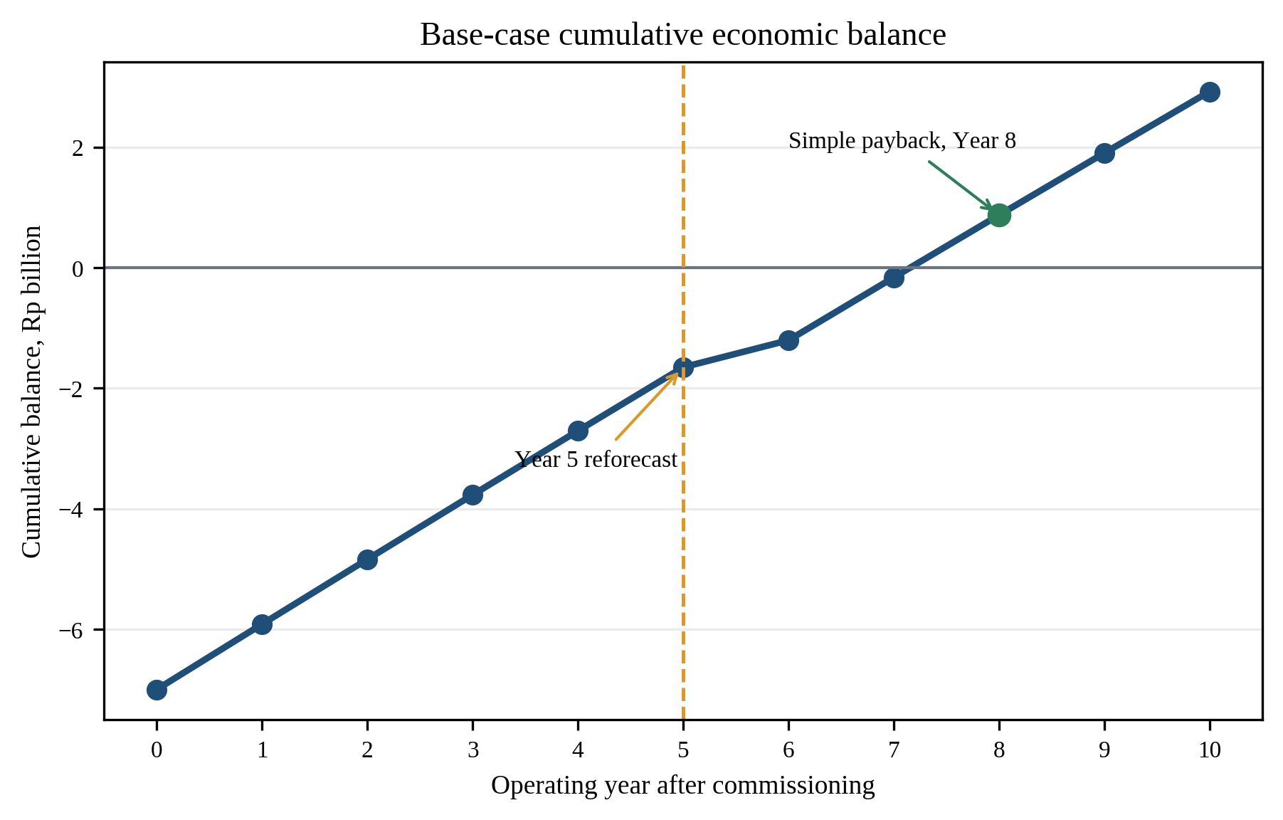
Appendix Figure A7-2. The Year 5 reforecast protects value before the planned overhaul and Year 8 payback.
Initial Year-0 CAPEX = Rp7.00 bn. Real NPV at 6% = Rp0.346 bn. simple payback = Year 8. levelized cost of recovered electricity = Rp1,158/kWh.

A7.4 Break-Even and Sensitivity Tests
Return to the related main-text section
Break-even thresholds
Threshold | Result | Interpretation
Minimum Year-1 recovery | 1.113 GWh/y | At Rp1,200/kWh and base costs
Minimum avoided value | Rp1,158/kWh | At 1.153 GWh/y and base costs
Maximum CAPEX | Rp7.346 bn | At base recovery, value, and O&M
Target versus minimum recovery | 0.040 GWh/y headroom | About 3.6% above break-even
Year-5 unrecovered capital | Rp1.653 bn | Reforecast yield, value, O&M, and overhaul
One-way sensitivity cases
Change from base | NPV (Rp bn) | Pass or fail | Change in NPV
Energy yield -25% | -2.148 | Fail | -2.494
Energy yield +25% | 2.841 | Pass | +2.494
CAPEX +20% | -1.054 | Fail | -1.400
CAPEX -20% | 1.746 | Pass | +1.400
Avoided value -15% | -1.150 | Fail | -1.497
Avoided value +15% | 1.843 | Pass | +1.497
O&M +25% | -0.206 | Fail | -0.552
Discount rate 10% | -0.840 | Fail | -1.186
Discount rate 4% | 1.079 | Pass | +0.733
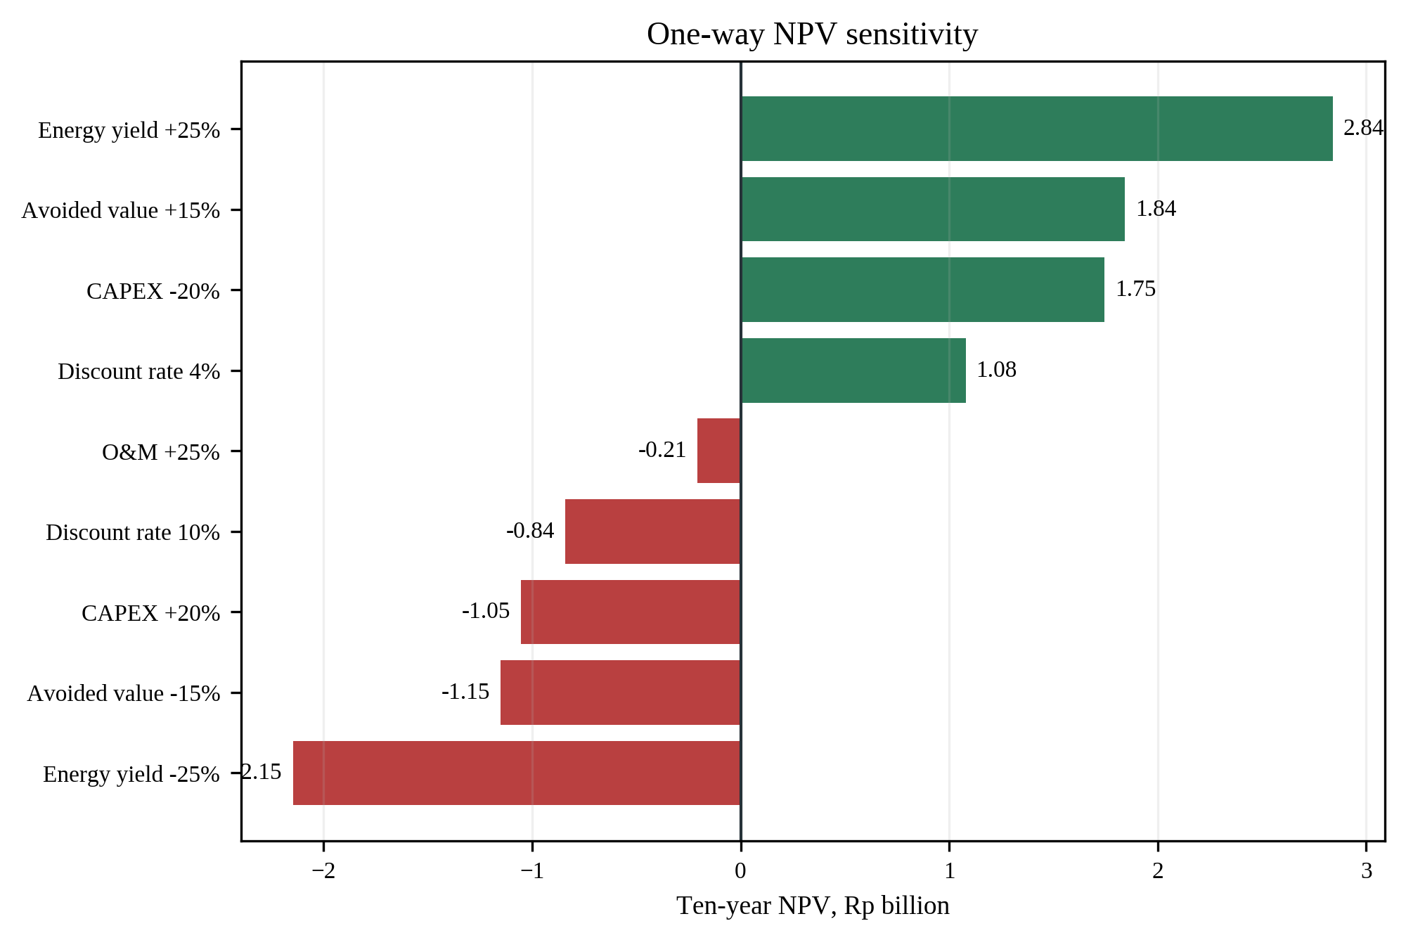
Appendix Figure A7-3. One-way NPV sensitivity identifies the downside cases Gate 2 must prevent.
Value-protection stack
Value risk | Design response | Protected outcome
Yield below screen | Baseline and activity audit before equipment award | Resize/exclude low-yield node. preserve shared platform
CAPEX above envelope | Competitive modules and Rp7.35 bn maximum award at base yield | Value engineer, retender, or stage the package
Avoided value changes | Prioritize direct local use at high-coincidence loads | Reforecast with actual bills. external service remains upside
O&M pressure | Common spares, local training, condition monitoring | Service-level warranty and planned overhaul reserve
Integration benefit is small | Independent site control remains functional | Keep local savings. aggregate only proven flexibility
Upside becomes available | Grid/peak/carbon revenue excluded from base | Add only after contract/regulatory verification
Economic interpretation. The base NPV is positive by Rp0.35 billion using energy savings alone. The conservative boundary leaves grid services, peak management, carbon value, and maintenance benefits as potential upside rather than requirements. A 25% yield shortfall, 20% CAPEX increase, 15% avoided-value reduction, 25% O&M increase, or 10% discount rate turns the unchanged package negative. The table above shows how the staged architecture responds before those conditions become fixed. ReGenCity's city standard and common platform remain scalable while each equipment module must earn inclusion. The result is an option-rich, downside-limited infrastructure program rather than an all-or-nothing bet.

A7.5 Monte Carlo Decision Experiment
Return to the related main-text section
Method. The model runs 20,000 reproducible trials (seed 20260724). Each engineering factor is sampled from a triangular distribution whose minimum, mode, and maximum equal the conservative, base, and optimized assumptions in Appendix 4. Financial ranges extend the one-way sensitivities. Inputs are sampled independently as a transparent first screen because no primary covariance data exist. Consequently, the results measure decision robustness under declared assumptions. they are not statistical forecasts of actual project performance.
Monte Carlo input ranges
Input | Distribution | Minimum | Mode | Maximum
Port factors | Triangular | Conservative inputs | Base inputs | Optimized inputs
Transit factors | Triangular | Conservative inputs | Base inputs | Optimized inputs
Water factors | Triangular | Conservative inputs | Base inputs | Optimized inputs
Water-node count | Discrete | 2 (25%) | 3 (50%) | 4 (25%)
CAPEX, Rp bn | Triangular | 6.30 | 7.00 | 8.40
Avoided value, Rp/kWh | Triangular | 1,020 | 1,200 | 1,380
Annual O&M, Rp bn | Triangular | 0.240 | 0.300 | 0.375
Year-6 overhaul, Rp bn | Triangular | 0.40 | 0.60 | 0.90
Real discount rate | Triangular | 4% | 6% | 10%
Annual degradation | Triangular | 0.2% | 0.5% | 1.0%
Monte Carlo output distribution
Output | P10 | P50 | P90 | Decision meaning
Ungated net recovery | 0.926 GWh | 1.181 GWh | 1.486 GWh | Before metering
Ungated 10-year NPV | Rp-2.320 bn | Rp0.026 bn | Rp2.898 bn | 50.6% at or above zero
Gate-qualified NPV | Rp0.112 bn | Rp1.658 bn | Rp4.075 bn | 91.9% at or above zero
Share qualifying for Gate 2 | - | 27.6% | - | Resize, retender, or stop non-qualifiers
Gate experiment. A trial qualifies when annual recovery is at least 1.113 GWh, CAPEX is no more than Rp7.346 billion, and documented avoided value is at least Rp1,158/kWh. The team observes these variables before full deployment through baseline metering, firm bids, and facility bills. The increase from 50.6% positive ungated trials to 91.9% among qualified trials quantifies the value of staged selection. The 27.6% qualifying share is not a predicted approval rate. The share reflects the deliberately broad assumed ranges.
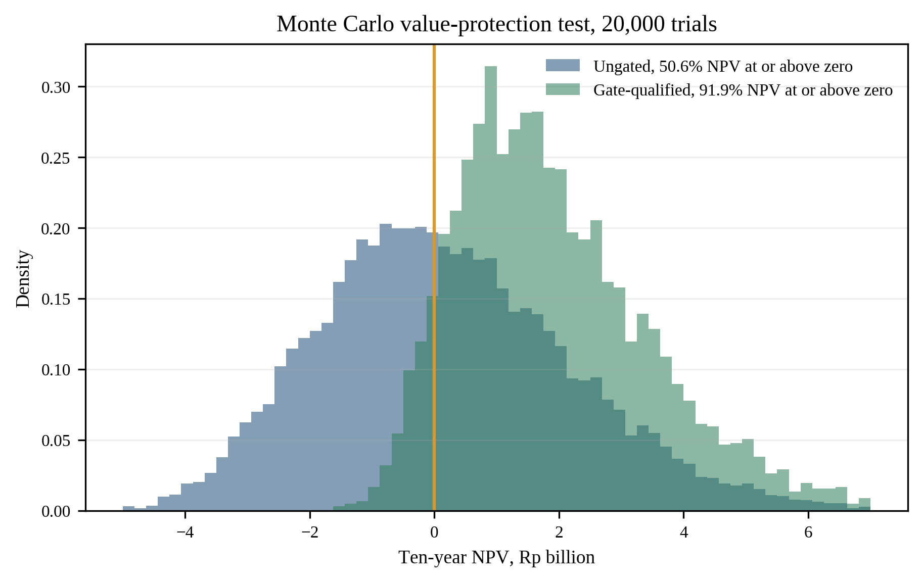
Appendix Figure A7-4. Gate qualification shifts the synthetic decision set toward positive NPV.
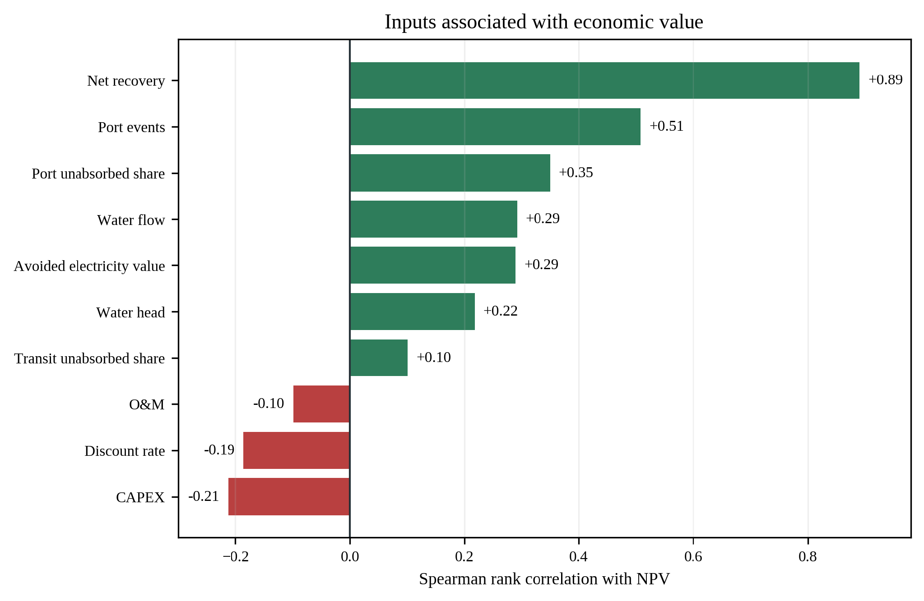
Appendix Figure A7-5. Rank-based drivers show where better measurements add the most decision value.
Priority variable | Spearman rho | Required action
Net recovery | +0.891 | Meter and reconcile site savings
Port events | +0.508 | Confirm eligible event volume
Port unabsorbed share | +0.350 | Audit existing regeneration
Water flow | +0.292 | Collect seasonal flow data
Avoided electricity value | +0.289 | Use actual facility bills
Water head | +0.218 | Measure head under service limits
The aggregate net-recovery correlation is large because net recovery includes the physical inputs shown beneath the aggregate. The factor-level drivers help decide where better measurements create the most value: port event/additionality data and water flow/head deserve early attention.
CAPEX has a negative rank association of -0.213. Gate 2 therefore caps firm bids before procurement.

A7.6 Scenario Interpretation
Return to the related main-text section
Engineering scenario | GWh/y | ktCO₂/y | NPV Rp bn | Decision signal
Conservative | 0.257 | 0.223 | -7.408 | Resize/reject at Rp7 bn
Base | 1.153 | 1.003 | 0.346 | Proceed at Rp7 bn
Optimized | 3.799 | 3.305 | 23.253 | Proceed at Rp7 bn
The optimized scenario identifies a credible upside route, but expansion follows only after field measurements independently validate its higher event, unabsorbed, efficiency, and hydraulic inputs.

A7.7 Energy and Emissions Impact
Return to the related main-text section
Scenario | GWh/y | MWh/y | tCO2/MWh | ktCO2/y | Status
Conservative | 0.257 | 257 | 0.87 | 0.223 | Screening projection
Base | 1.153 | 1,153 | 0.87 | 1.003 | Screening projection
Optimized | 3.799 | 3,799 | 0.87 | 3.305 | Screening projection
Operating checkpoints
Checkpoint | Recovered energy or flexibility | Operational avoidance | Boundary
Annual base | 1.153 GWh | 1.003 ktCO2 | Before embodied impacts
Operating Years 1 to 5 | 5.705 GWh | 4.964 ktCO2 | Includes 0.5% annual degradation
Operating Years 1 to 10 | 11.270 GWh | 9.805 ktCO2 | Factor held constant
Qualified flexibility target | 1.30 MW for 15 min | No extra MWh counted | Energy and power stay separate
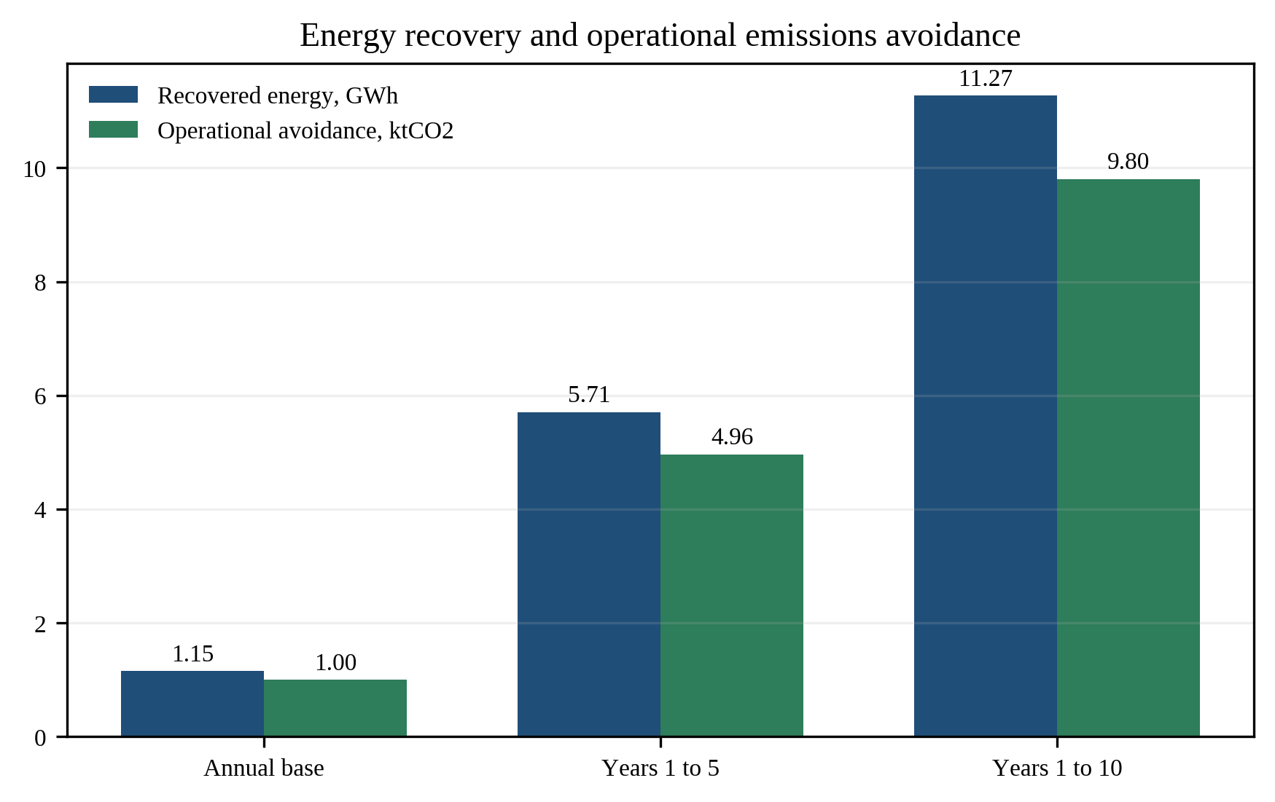
Appendix Figure A7-6. The impact scale grows with the operating horizon and remains an operational claim.
Emissions formula. Avoided operational emissions = verified net MWh × applicable grid emissions factor. The 0.87 tCO₂/MWh factor is used for screening consistency. Final reporting must record the factor's year and method, and must separately disclose embodied emissions of storage, converters, civil works, replacements, and end-of-life treatment.
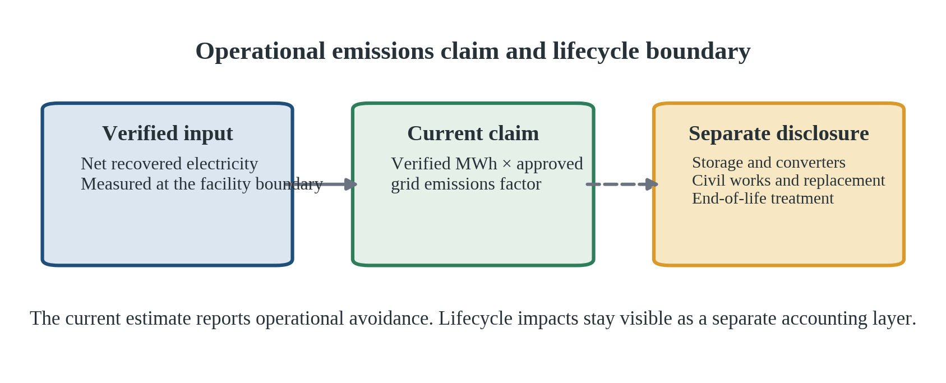
Appendix Figure A7-7. Operational avoidance and lifecycle impacts use separate accounting boundaries.

Appendix 8. Risk and Controls

A8.1 Method and Rating Scale
Return to the related main-text section
Each risk is rated as likelihood (1 rare-5 almost certain) × impact (1 minor-5 critical). Scores 1-4 are Low, 5-9 Moderate, 10-16 High, and 17-25 Critical. Pre-control ratings are screening judgements. Residual ratings are control targets-not observed performance-and must be reassessed at each gate. High-severity risks retain impact 5 when controls reduce likelihood but not consequence.
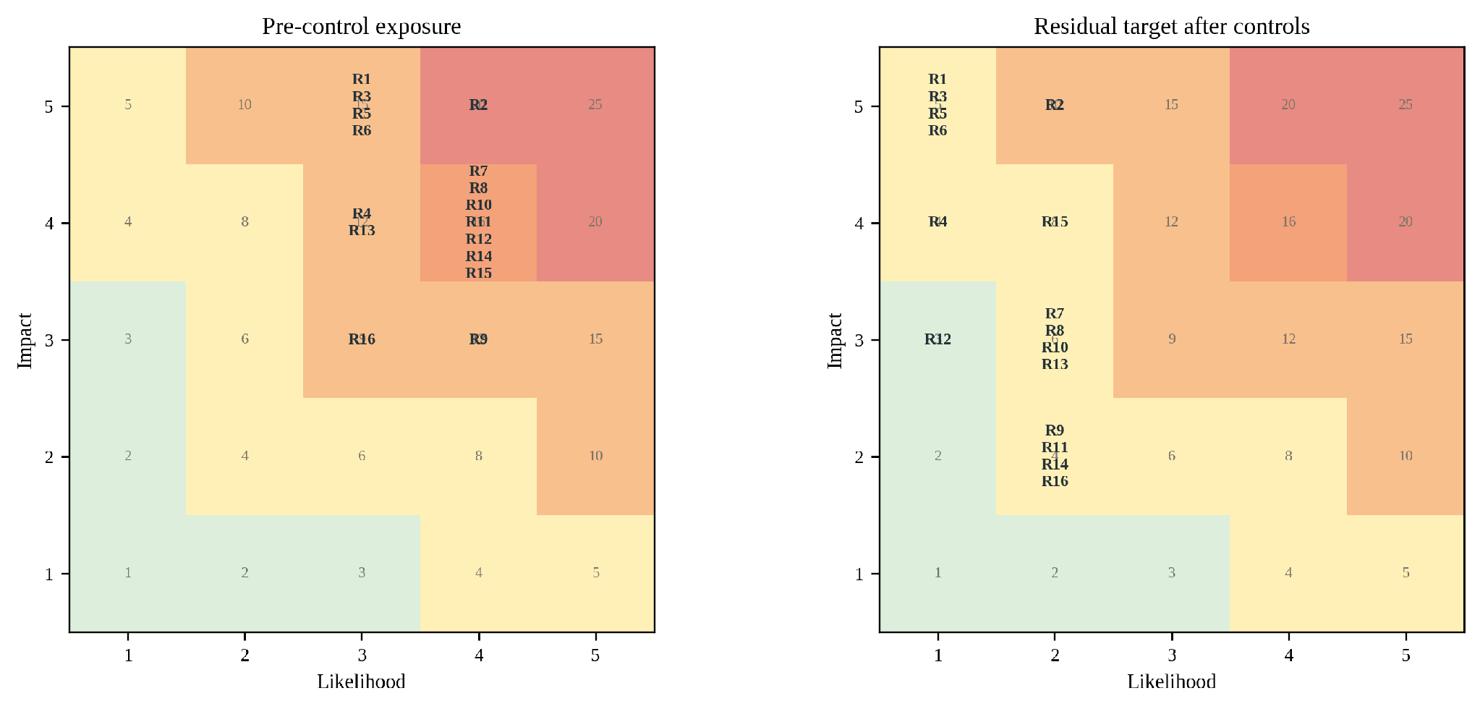
Appendix Figure A8-1. Pre-control exposure and residual targets use the same likelihood-impact scale.
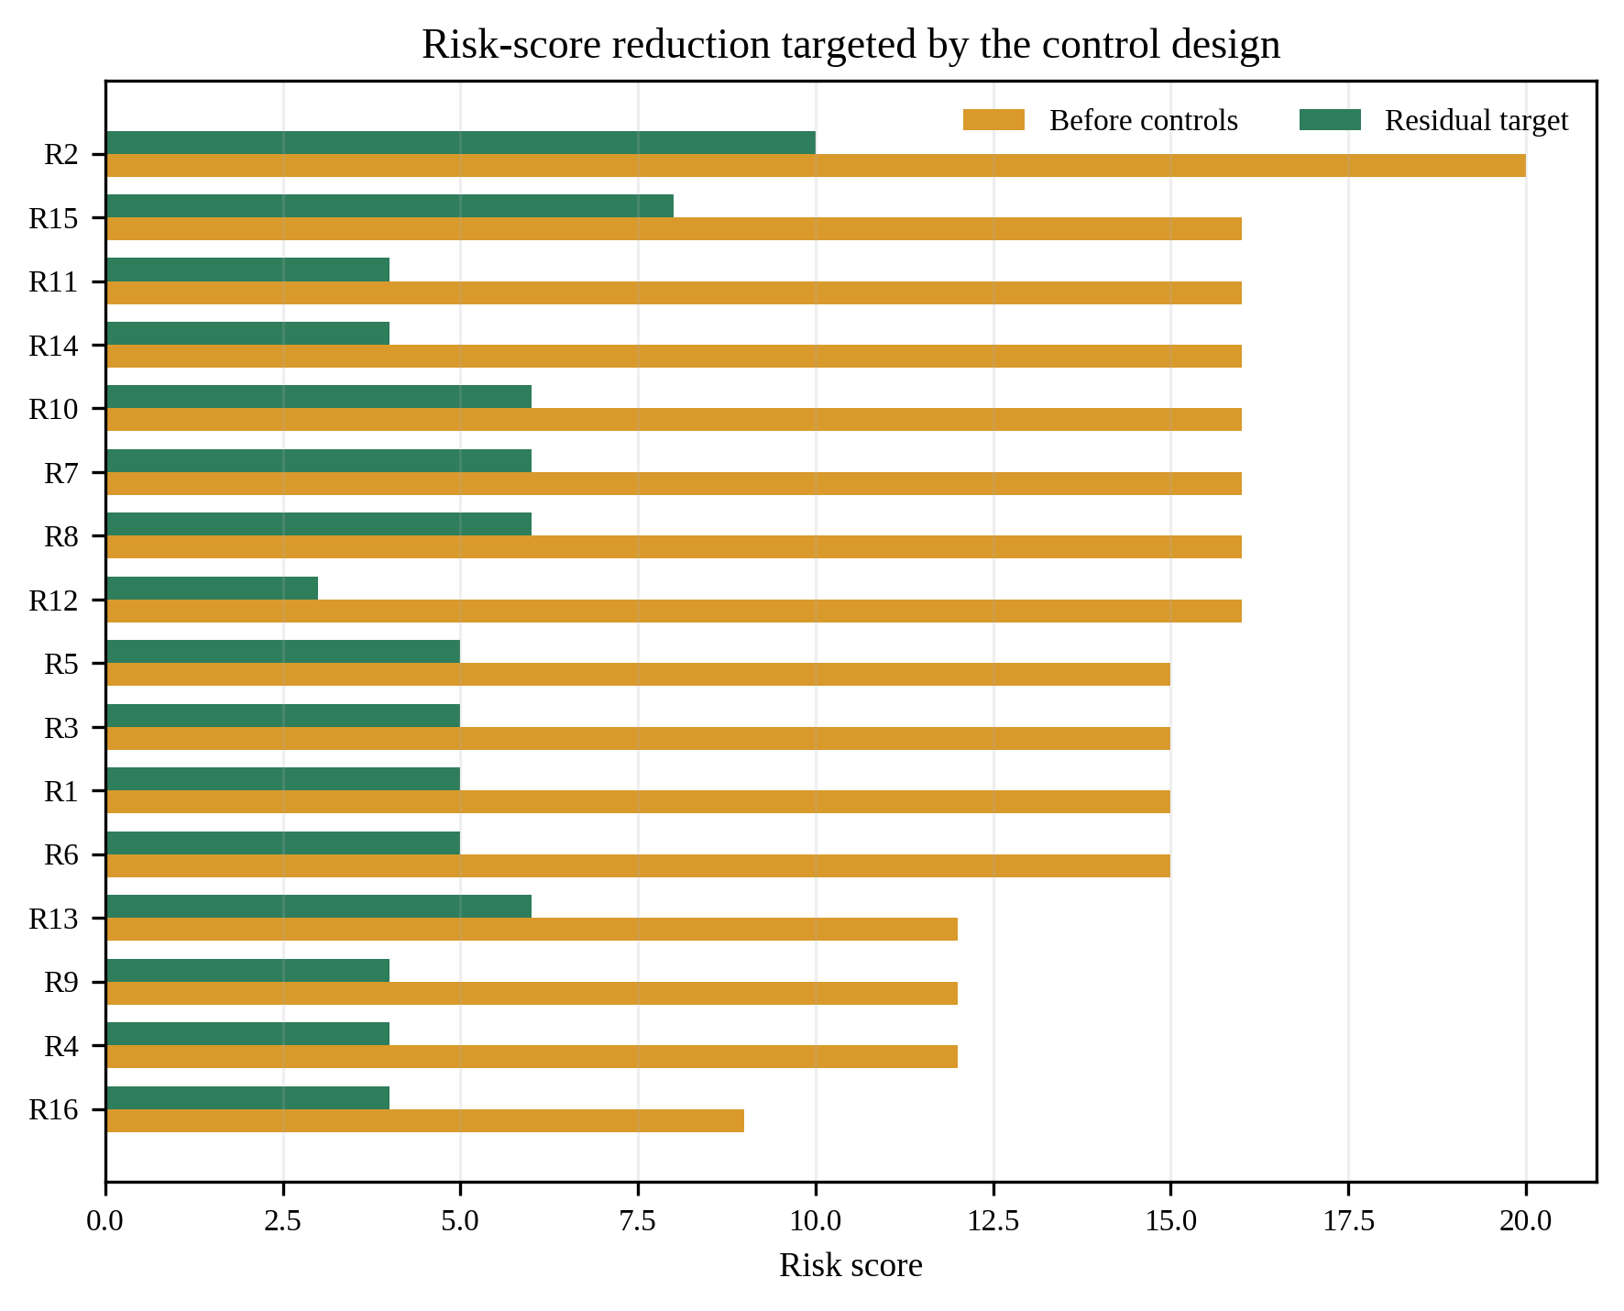
Appendix Figure A8-2. Control measures reduce likelihood while high-consequence impacts stay visible.

A8.2 Detailed Risk Mitigation Register
Return to the related main-text section
Risks R1-R8
Risk | Description / trigger | Preventive and detective controls | Pre to residual target / response owner
R1. Functional-safety interlock failure | Invalid ReGenCity request is accepted. unsafe converter or hydraulic state. | Independent hardwired limits. safety PLC. proof testing. command allow-list. failure injection. | 3×5=15 to 1×5=5  Trip and isolate. owner safety lead
R2. Cyber compromise / unauthorized dispatch | Credential, gateway, or supply-chain compromise crosses an operational boundary. | Segmentation. least privilege. MFA. signed firmware/commands. monitoring. offline fallback. incident drills. | 4×5=20 to 2×5=10  Revoke access and isolate node. cyber lead
R3. Storage or electrical fire | Thermal runaway, protection failure, arc event, or inadequate ventilation. | Certified system. BMS. thermal/gas detection. separation. suppression plan. emergency access. | 3×5=15 to 1×5=5  Emergency isolation/response. asset owner
R4. Port-throughput interference | Recovery/storage constraint delays crane cycle or equipment availability. | No dispatch outside envelope. direct-use priority. shadow tests. throughput SLA. operator veto. | 3×4=12 to 1×4=4  Bypass ReGenCity. port operations
R5. Transit service disruption | Wayside equipment or command affects traction voltage, braking acceptance, or timetable. | Rail safety case. protection coordination. offline mode. maintenance windows. staged service tests. | 3×5=15 to 1×5=5  Isolate system. rail control
R6. Water pressure or quality breach | Turbine changes minimum pressure, transients, redundancy, or sanitary condition. | Hydraulic model. bypass. pressure protection. materials approval. water-quality and surge tests. | 3×5=15 to 1×5=5  Automatic bypass. water operations
R7. Additionality below forecast | Existing regeneration or operating profile leaves too little net recoverable energy. | Meter first. measure unabsorbed fraction. conservative normalization. module-level threshold. | 4×4=16 to 2×3=6  Resize/reject module. verifier + gate board
R8. CAPEX / procurement overrun | Bids, civil works, imports, or schedule exceed the break-even envelope. | Open modular packages. firm pricing. contingency. value engineering. stop before award. | 4×4=16 to 2×3=6  Reduce scope or retender. program office
Risks R9-R16
Risk | Description / trigger | Preventive and detective controls | Pre to residual target / response owner
R9. Interoperability / vendor lock-in | Proprietary interfaces block replacement, data access, or multi-vendor dispatch. | Open data model. conformance tests. source/data escrow. export rights. replaceability test. | 4×3=12 to 2×2=4  Operate locally. replace interface. integrator
R10. Data quality / rights failure | Missing, unsynchronized, inaccessible, or contractually restricted data invalidates M&V. | Data contract. clock sync. validity dashboard. raw export. backup meter. quality gate. | 4×4=16 to 2×3=6  Extend baseline/suspend claims. owner + verifier
R11. Grid-service pathway unavailable | Tariff, interconnection, aggregator, or market rules do not permit external service. | Base case uses local savings only. early utility consultation. bounded sandbox. | 4×4=16 to 2×2=4  Remain behind meter. program office
R12. M&V double counting | Device output and storage discharge or overlapping feeders inflate impact. | One-count rule. feeder boundary map. frozen M&V plan. independent reconciliation. | 4×4=16 to 1×3=3  Restate results. independent verifier
R13. Partner withdrawal / governance deadlock | One owner exits or approval authority remains unclear. | Module separability. decision rights. exit clauses. escrowed data. gate quorum. | 3×4=12 to 2×3=6  Continue viable modules or close. gate board
R14. AI drift / wrong setpoint | Forecast or model change degrades value or recommends unsuitable action. | Rule-based benchmark. envelope constraints. drift monitor. version approval. explainable logs. | 4×4=16 to 2×2=4  Revert to rule control. site optimizer lead
R15. Flood / saline-corrosion damage | North-coast exposure damages electronics, storage, sensors, or communications. | Elevation. ingress rating. corrosion class. drainage. environmental monitoring. spares. | 4×4=16 to 2×4=8  Isolate/replace. asset maintenance
R16. O&M skills / spares shortage | Specialist dependency causes prolonged outage or unsafe workarounds. | Training/certification. maintenance plan. local spares. manuals. remote-support limits. | 3×3=9 to 2×2=4  Safe shutdown. owner maintenance

A8.3 Safety and Service Assurance Tests
Return to the related main-text section
Test | Acceptance outcome | When
Loss of ReGenCity communications | Node remains stable and local primary function continues | Gate 3
Invalid/out-of-envelope command | Command rejected and logged. no actuator effect | Gate 3
Meter/sensor disagreement | Degraded mode. claim suspended. safe control continues | Gate 3
Storage high temperature/fault | Automatic isolation. defined emergency response | Gate 3 + quarterly
Port peak operation | No measurable throughput/service degradation | Shadow and bounded live
Transit abnormal timetable | No effect on traction safety/service. envelope shrinks | Shadow and bounded live
Water low-demand/pressure event | Bypass maintains minimum pressure and quality | Commissioning + seasonal
Manual operator veto | Immediate, authoritative, and auditable | Every site acceptance
Black start / power restoration | Safe sequence. no unintended dispatch | Site acceptance
Flood/ingress simulation or inspection | Enclosure/drainage/protection remain effective | Before wet season + annual

A8.4 OT Cybersecurity Control Profile
Return to the related main-text section
Function | Minimum controls | Evidence
Govern | Named asset owner, risk acceptance, supplier obligations, data retention, incident authority | Charter/contract review
Identify | Asset inventory, data-flow map, criticality, dependencies, firmware/SBOM | Baseline and change control
Protect | Segmentation, least privilege, MFA, jump host, signed updates, secure configuration, backup | Conformance and penetration tests
Detect | Time-synchronized logs, anomaly rules, failed-command alerts, integrity monitoring | Alert drills and log audit
Respond | Site isolation, credential revocation, owner-led incident command, regulator notification path | Tabletop + technical exercise
Recover | Known-good images, configuration restore, manual operation, evidence preservation, lessons learned | Recovery-time test
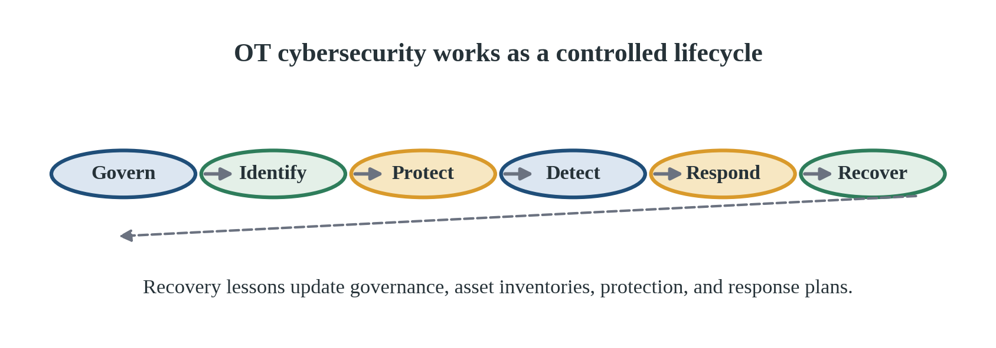
Appendix Figure A8-3. Govern, identify, protect, detect, respond, and recover form one OT control cycle.

A8.5 Incident Classification and Disclosure
Return to the related main-text section
Level | Definition | Required response
Level 0 | Near miss / rejected command. no effect | Log, weekly review, corrective action if recurrent
Level 1 | Minor technical degradation. no service/safety effect | Owner response. verifier notified. claim window flagged
Level 2 | Service KPI breach or contained cyber/safety event | Suspend live dispatch. gate-board review before restart
Level 3 | Material safety, water-quality, rail, port, or cyber incident | Emergency response. system isolation. external notification as required. independent investigation

Appendix 9. KPI Dictionary and Evidence-Gated Replication

A9.1 Pilot KPI Dictionary
Return to the related main-text section
KPI | Definition | Unit | Gate/target | Owner
K1 Net recovered electricity | Adjusted baseline import minus post-retrofit import | MWh/y | >=800. target 1,153 | Verifier
K2 Data validity | Valid required intervals ÷ expected intervals | % | >=95% | Verifier/data lead
K3 Portfolio uncertainty | Combined uncertainty of annual net result | % | <=10% | Verifier
K4 Qualified flexibility | Verified power sustained for the stated duration | MW / min | >=1.0. target 1.3 / 15 | Verifier + owners
K5 Call success | Successful qualified calls ÷ requested calls | % | >=90% | System operator
K6 Integration dividend | Value gain from coordinated versus independent control | % | Target >=5% | Verifier
K7 AI incremental value | AI value gain over rule control, net of costs | % | Target >=3%. otherwise rule | Data/model lead
K8 Facility peak import | Comparable-period peak import change | kW / % | Report. no double count | Owner and verifier
K9 Availability | Capable operating hours ÷ required hours | % | Defined by module SLA | Asset owner
K10 Conversion yield | Delivered recovery ÷ eligible physical potential | % | Report by anchor | Owner and verifier
K11 Service effect | Throughput, timetable, pressure, or quality deviation | Domain KPI | No material adverse effect | Asset owner
K12 Safety events | Recordable event attributable to ReGenCity | Count | 0 | Owner safety lead
K13 Cyber incidents | Confirmed compromise affecting confidentiality, integrity, or availability | Count/severity | 0 material | Cyber lead
K14 Avoided operational emissions | K1 × current approved grid factor | tCO₂/y | Report with factor/version | Verifier
K15 Cost of recovered energy | Discounted lifecycle cost ÷ discounted net kWh | Rp/kWh | <= avoided-value threshold | Finance lead
K16 Module NPV | Discounted net savings less lifecycle cost | Rp bn | >=0 for scale module | Finance + gate board
K17 Operator competence | Staff passing role tests and drills | % staff | 100% required roles | Asset owner
K18 Replication effort | Engineering hours and cost per approved module | Hours/Rp | Declining without risk dilution | Program office
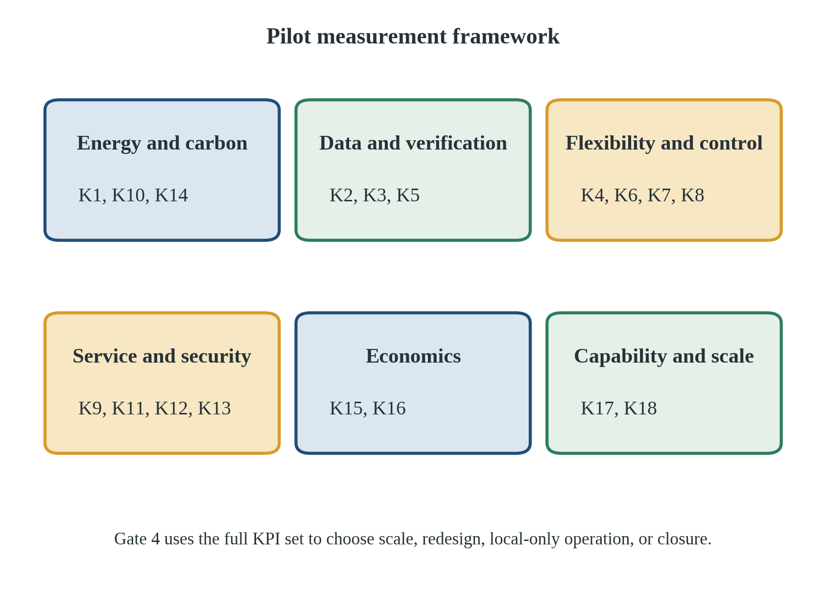
Appendix Figure A9-1. The KPI set connects energy, verification, flexibility, service, economics, and scale.

A9.2 Evidence Packages at Month 24
Return to the related main-text section
Package | Required contents | Decision question
EP-1 Engineering | As-built diagrams. protection settings. hydraulic/electrical studies. FAT/SAT. change log | Assets operate inside approved limits
EP-2 Energy M&V | Frozen plan. raw exports. baseline model. adjustments. uncertainty. net results | Energy claim is auditable
EP-3 Flexibility | Envelope method. event logs. SOC. duration. call-success test | Power claim is qualified, not nameplate
EP-4 Service/safety | Domain KPIs. incidents. drills. owner sign-off. residual risk acceptance | No burden shifted to primary service
EP-5 Cyber/data | Asset/data-flow inventories. control tests. incidents. recovery exercise. access audit | Federated control remains bounded
EP-6 Economics | Final invoices. O&M. applicable bills. revised 10-year model. sensitivity | Module clears financial gate
EP-7 Replication | Open specification. tender clauses. training pack. candidate method. lessons learned | Next site reuses verified knowledge

A9.3 Replication Decision Matrix
Return to the related main-text section
Decision | Minimum evidence state | Action
Scale module | Safety/service pass. K1/K2/K3 pass. module NPV >=0. controls effective | Replicate the approved module in wider Jakarta with updated coefficients
Redesign and retest | Core opportunity remains but one remediable technical/economic threshold fails | One bounded corrective cycle. no public impact claim during retest
Operate locally, do not aggregate | Local savings pass but qualified-flexibility or cyber/integration gate fails | Retain safe behind-meter value. exclude from portfolio
Stop module | Additionality, safety, service, owner, or economic gate fails materially | Close and document negative result. do not cross-subsidize
Advance to city screening | At least two anchor types pass with stable M&V and reusable interfaces | Screen wider Jakarta. then other cities using measured URecI bands

A9.4 City-Level Recoverability Screening After the Pilot
Return to the related main-text section
Screening dimension | Evidence required | Anti-overclaim control
Asset density | Count of comparable port/transit/water assets with preliminary gate evidence | Do not use city population as a proxy
Measured recovery coefficients | Pilot-derived kWh/event or kWh per Q-H-hour with uncertainty | Transfer only to comparable regimes
Grid/local-load value | Applicable avoided value, coincidence, congestion, and local demand | Keep grid revenue separate
Institutional readiness | Owner authority, data rights, safety regulation, procurement path | Mandatory gate, not a score booster
Climate/physical exposure | Flood, heat, corrosion, seismic, and access conditions | Adjust design and cost before ranking
Workforce/supply chain | Certified operators, maintainers, local spares, vendor diversity | Include lifecycle, not installation only
Equity/public value | Service reliability, benefit distribution, transparency, burden | No energy gain excuses service harm
Scale pathway. North Jakarta is the evidence-generating pilot. wider Jakarta is the first replication field. other Indonesian cities are considered only after measured coefficients, costs, residual risks, and interface performance are available. The output forms an uncertainty-aware shortlist of modules passing the same service-first gates, not a national league table.

